<https://www.youtube.com/watch?v=sHRBg6BhKjI&list=PLblh5JKOoLUK0FLuzwntyYI10UQFUhsY9&index=38>

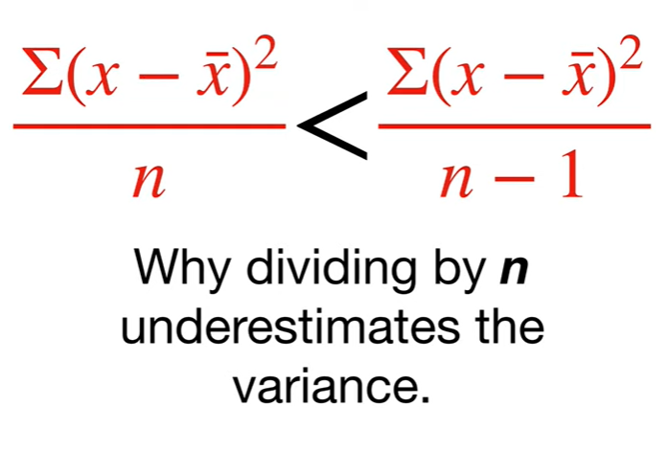

Today we're going to talk about why dividing by n underestimates the variance.

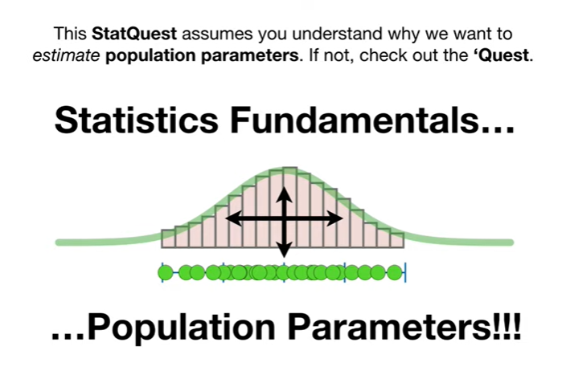

This stack quest assumes you already understand why we want to estimate population parameters.

If not check out the quest.

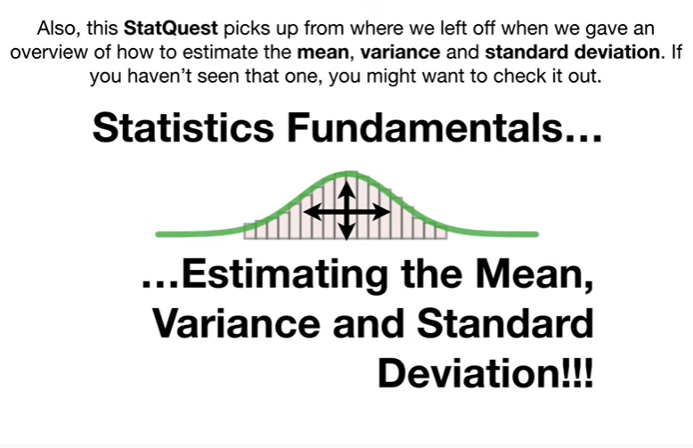

Also this stack quest picks up from where we left off when we gave an overview of how to estimate the mean variance and standard deviation.

If you haven't seen that one you might want to check it out getting up from where we left off

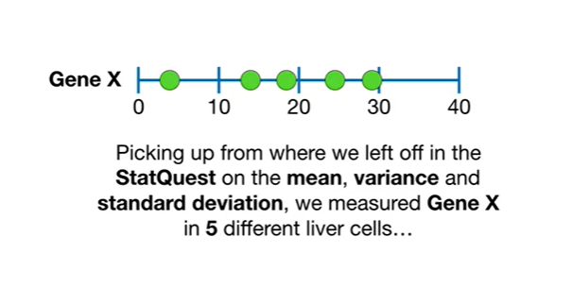

In the stat quest on the mean variance and standard deviation we measured gene X in five different liver cells

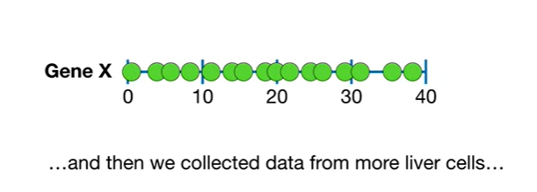

and then we collected data from more liver cells

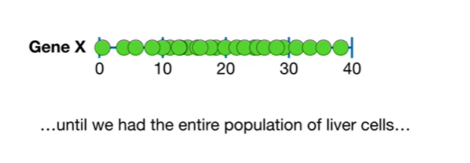

until we had the entire population of liver cells

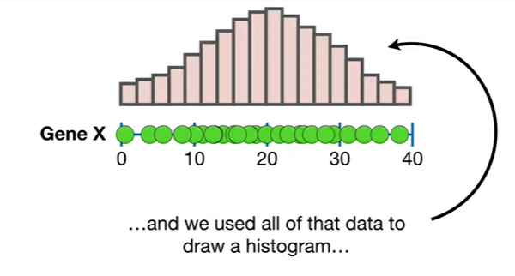

and we used all of that data to draw a histogram

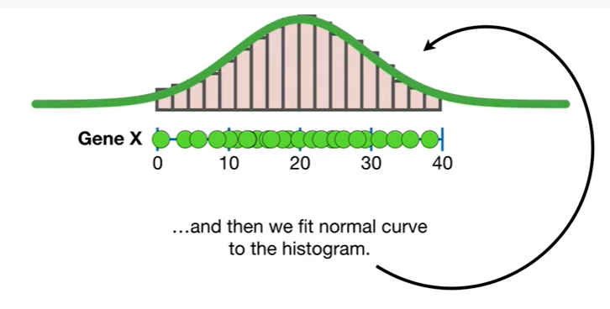

and then we fit a normal curve to the histogram.

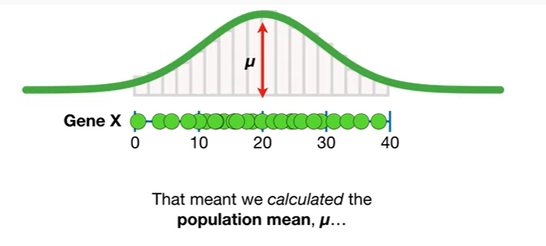

That meant we calculated the population mean mu.

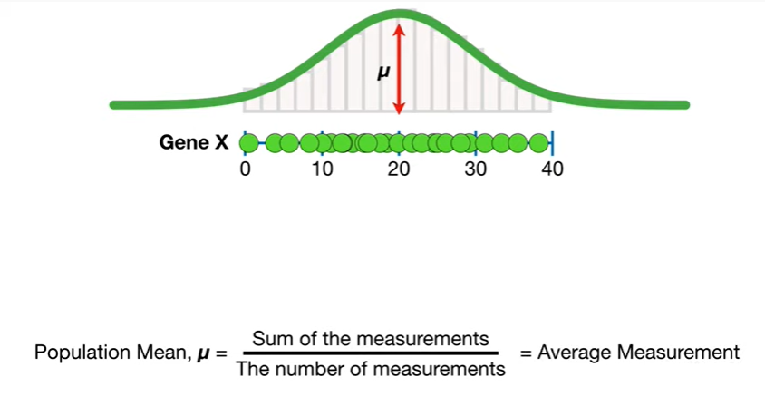

The population mean mu equals the sum of the measurements divided by the number of measurements which equals the average measurement mu.

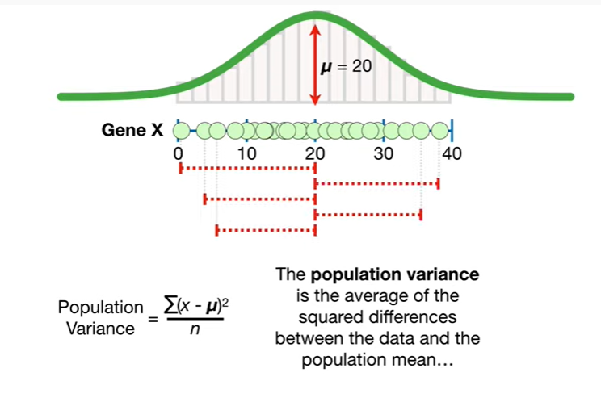

And we calculated the population variance in standard deviation the population variance is the average of the squared distances between the data and the population mean

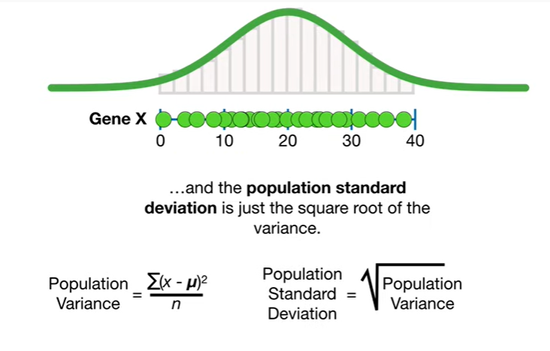

and the population standard deviation is just the square root of the variance.

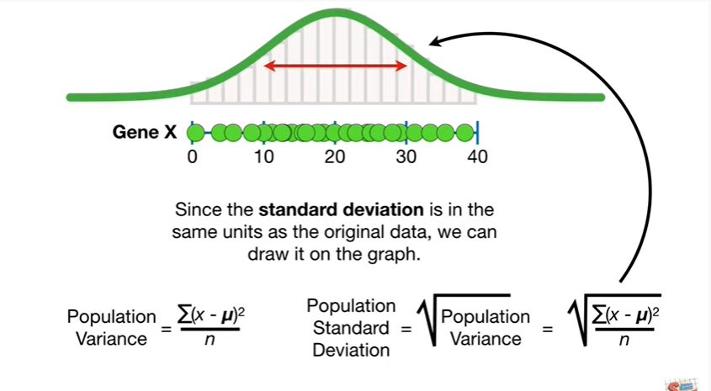

Since the standard deviation is in the same units as the original data we can draw it on the graph.

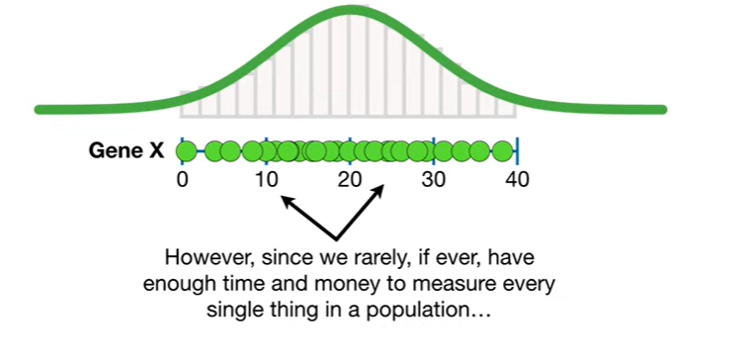

However since we rarely if ever have enough time and money to measure every single thing in a population

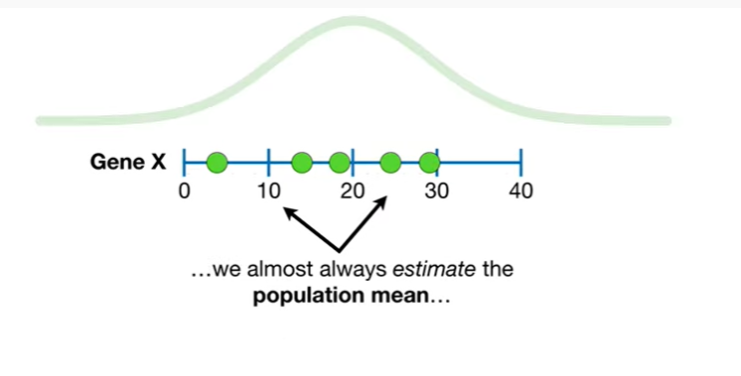

we almost always estimate the population mean.

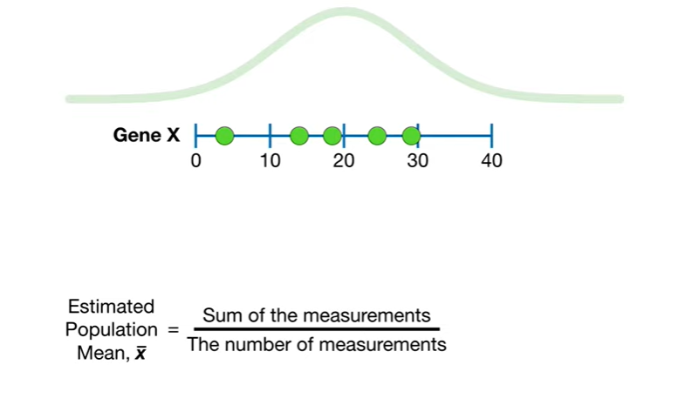

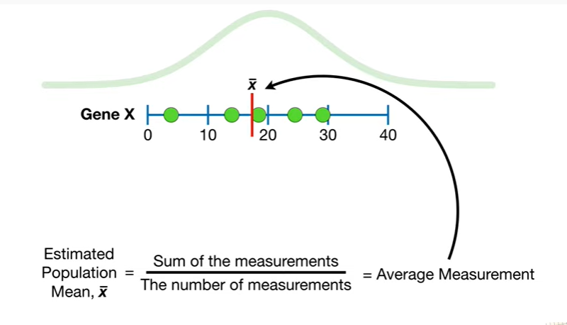

The estimated population mean x-bar equals the sum of the measurements divided by the number of measurements and that equals the average measurement x-bar

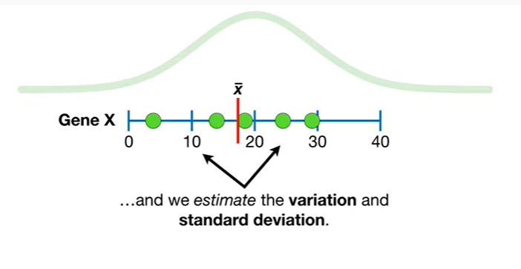

and we estimate the variation and standard deviation.

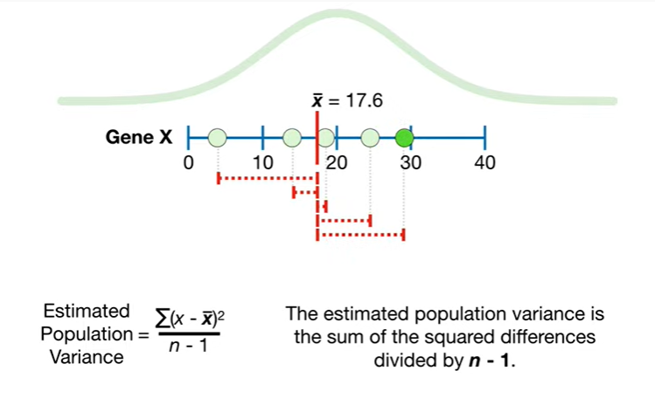

The estimated population variance is the sum of the squared differences divided by n minus 1.

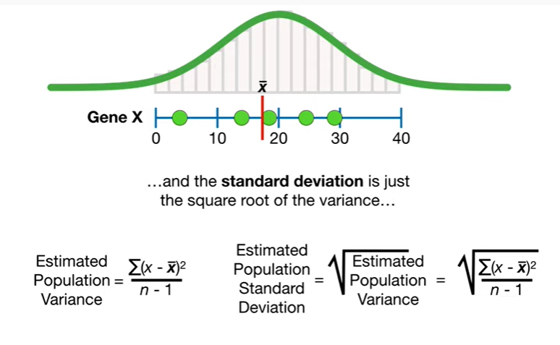

And the standard deviation is just the square root of the variance

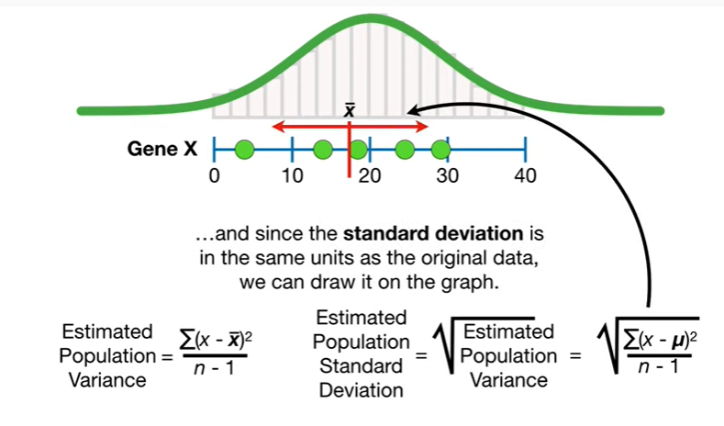

and since the standard deviation is in the same units as the original data we can draw it on the graph.

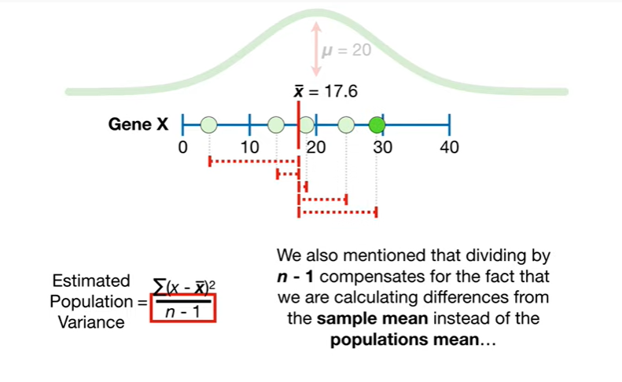

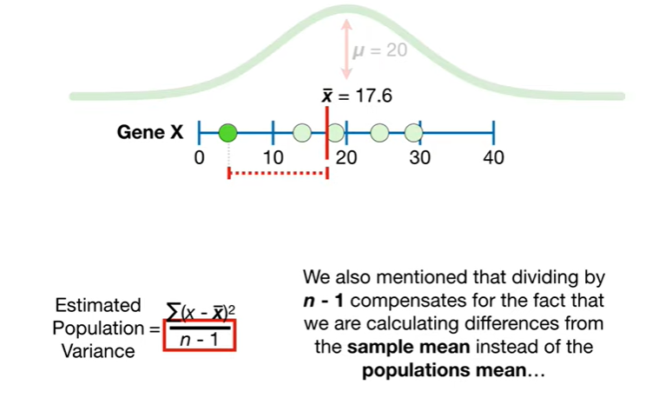

We also mentioned that dividing by IDI minus one compensates for the fact that we are calculating differences from the sample mean instead of the population mean.

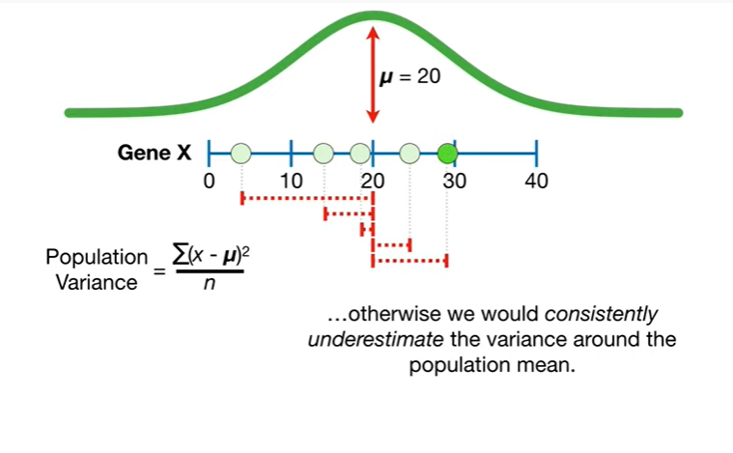

Otherwise we would consistently underestimate the variance around the population mean.

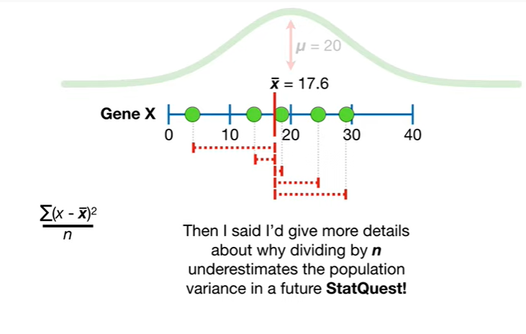

Then I said I'd give more details about why dividing by n underestimates the population variance in a future stat quest !

The future is now.

BAM !!!!

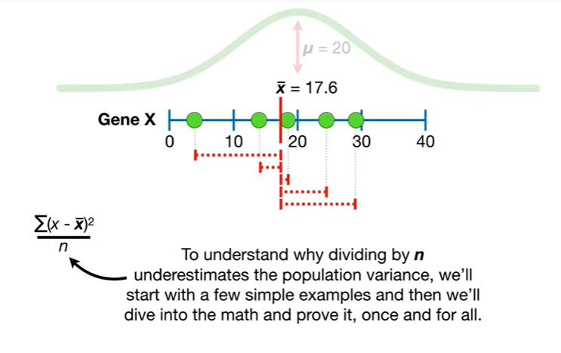

To understand why dividing by n underestimates the population variance we'll start with a few simple examples and then we'll dive into the math and prove it once and for all.

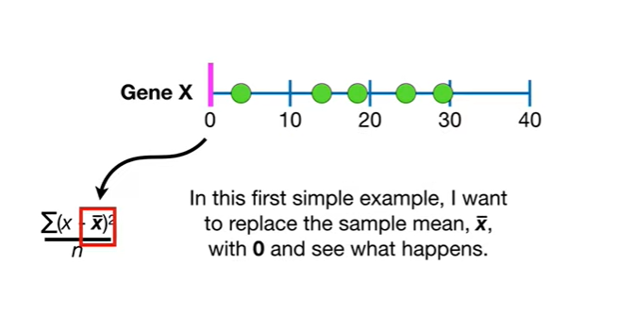

In this first example I want to replace the sample mean x-bar with zero and see what happens.

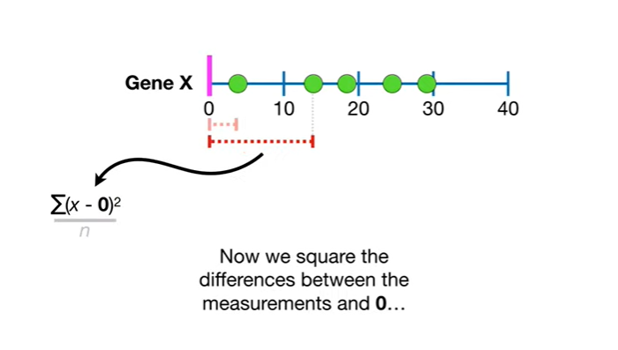

Now we square the differences between the measurements and zero

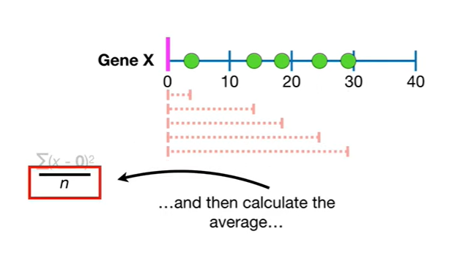

calculate the average

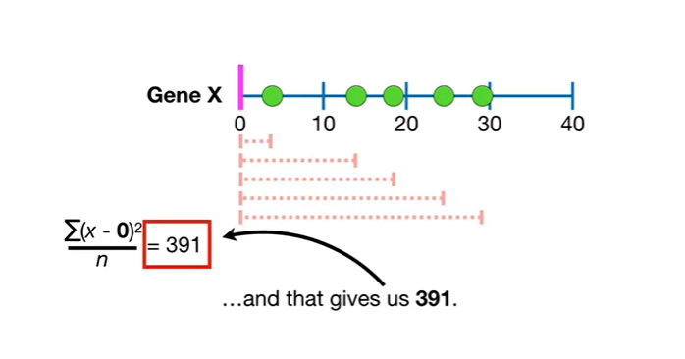

and that gives us 391.

BAM !!!

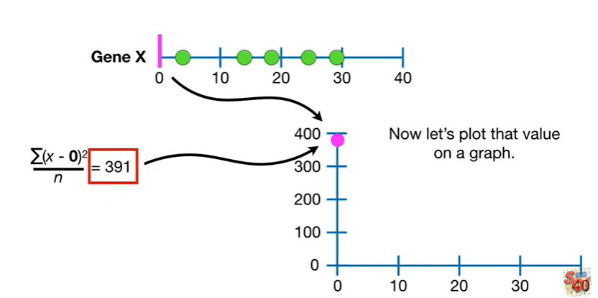

Now let's plot that value on a graph.

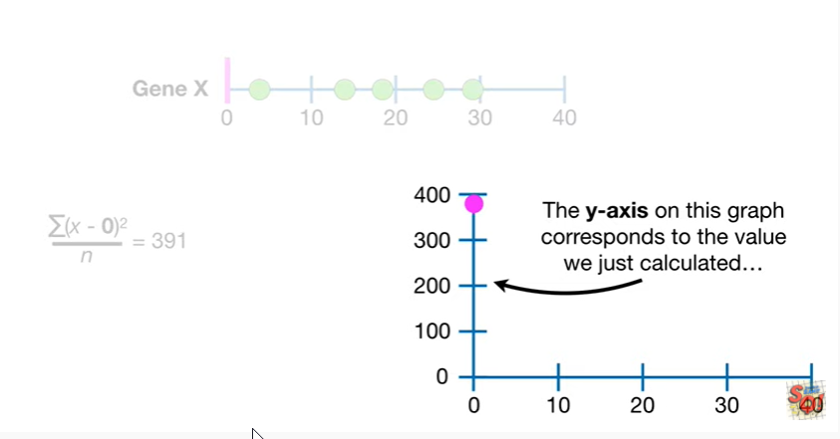

The y-axis on this graph corresponds to the value we just calculated.

Tt is the variance around a specific point.

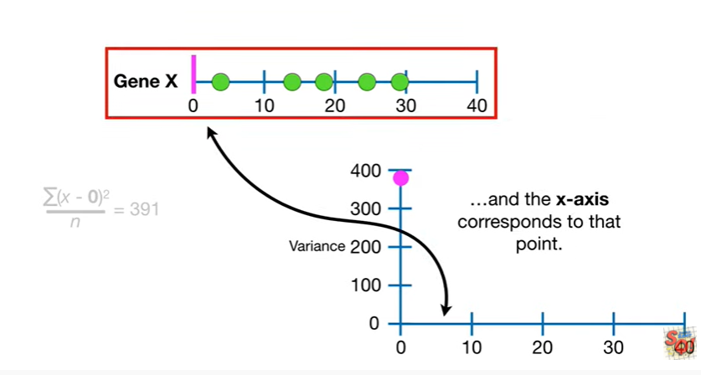

And the x-axis corresponds to that point.

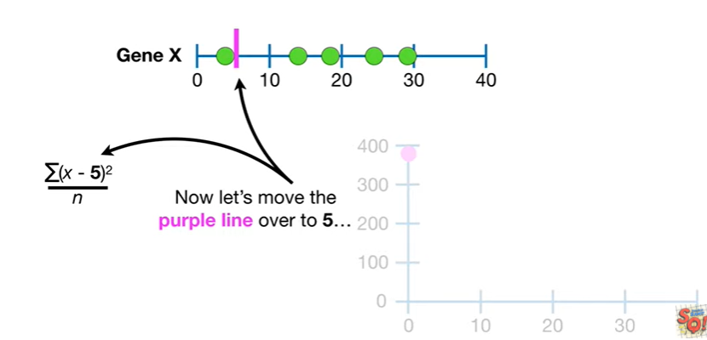

Now let's move the purple line over to five

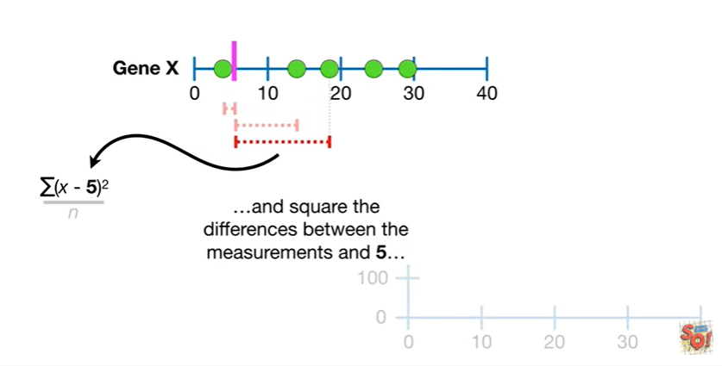

and square the differences between the measurements and five

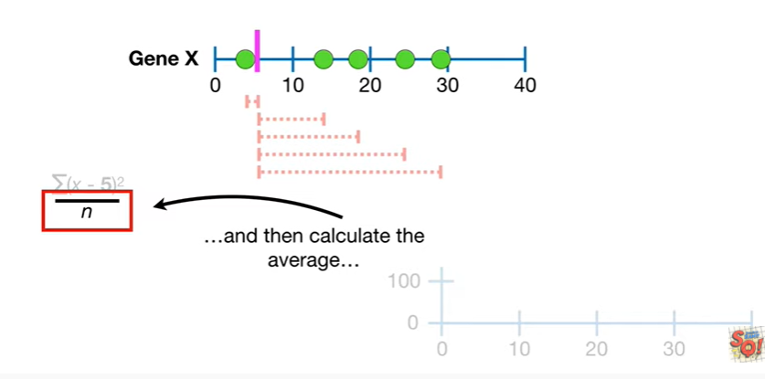

and then calculate the average

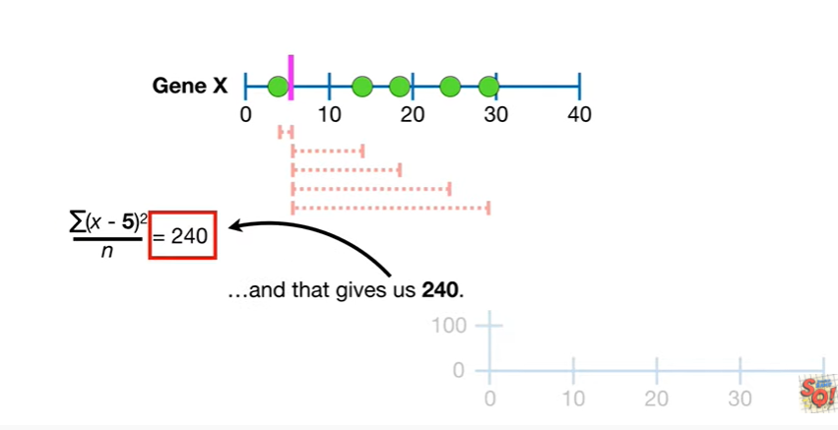

and that gives us 240.

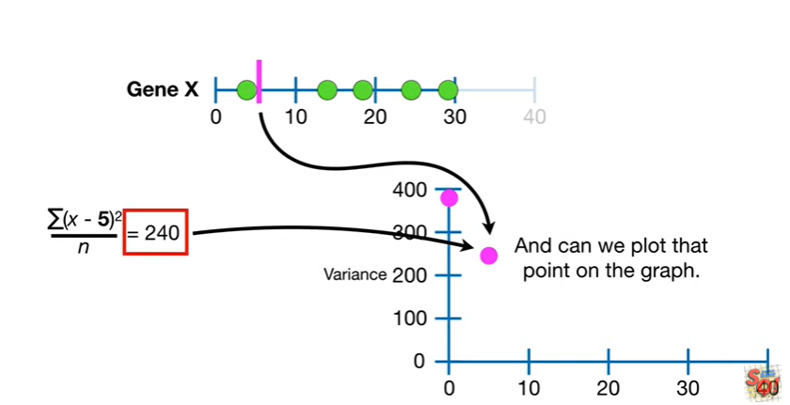

And we can plot that point on the graph.

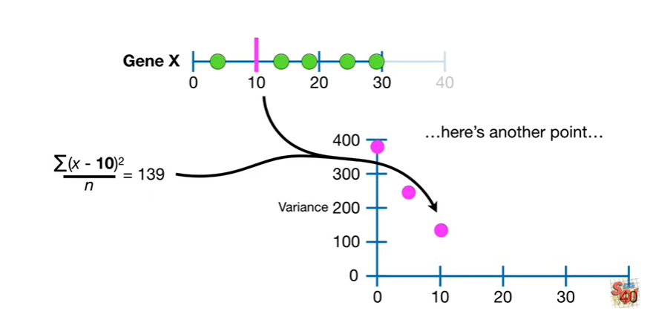

Here's another point

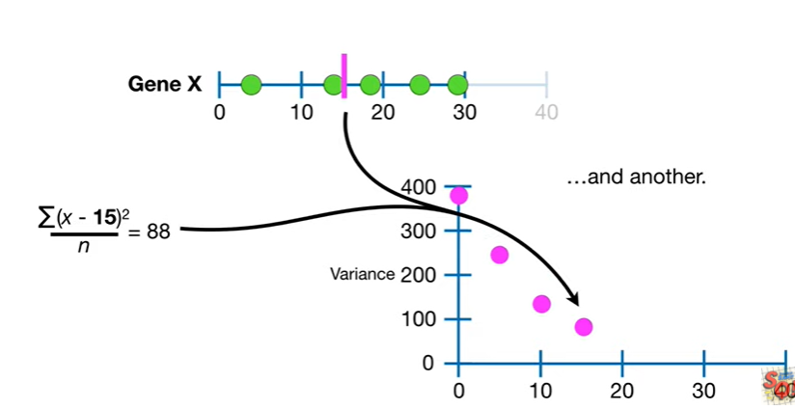

and another.

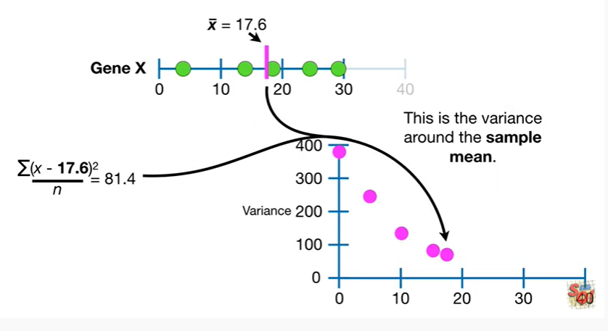

And this is the variance around the sample mean.

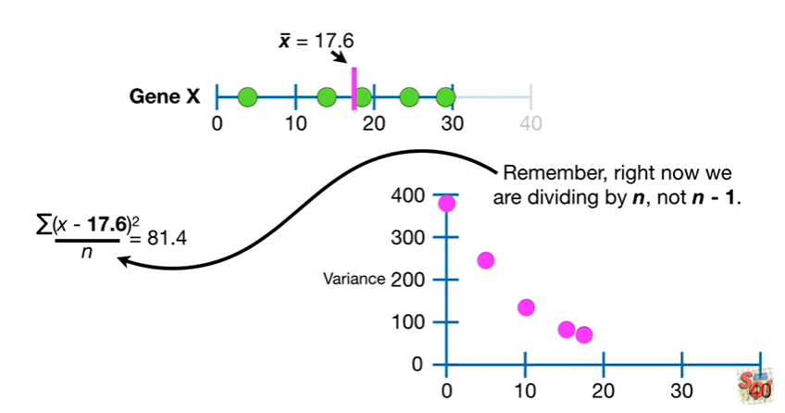

Remember right now we are dividing by n not n minus 1.

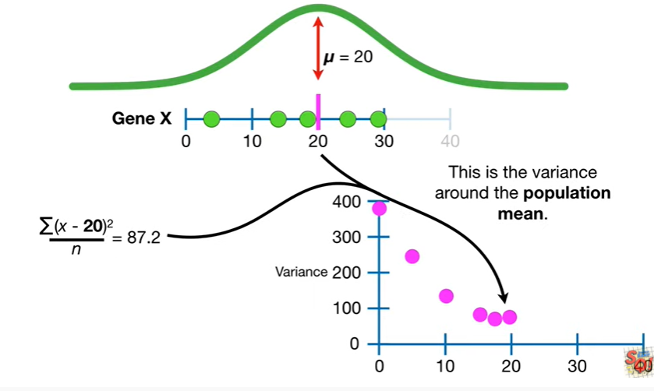

This is the variance around the population mean

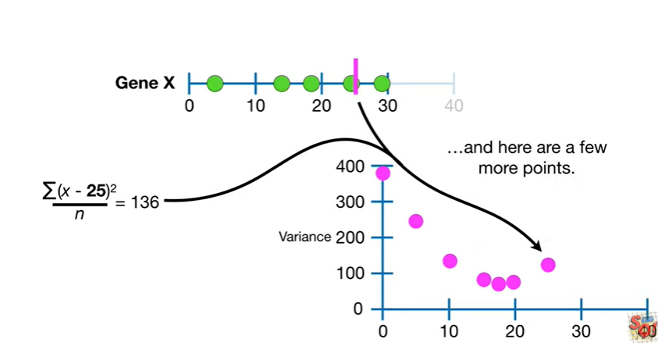

and here are a few more points.

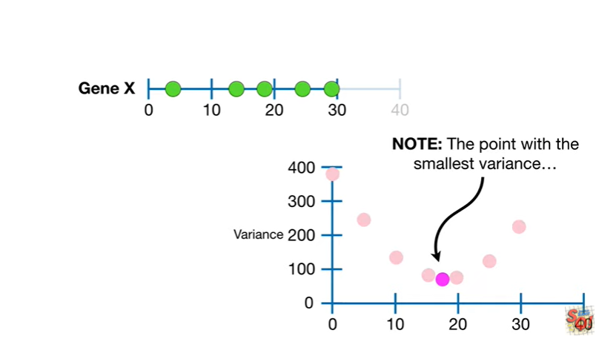

Note : the point with the smallest variance

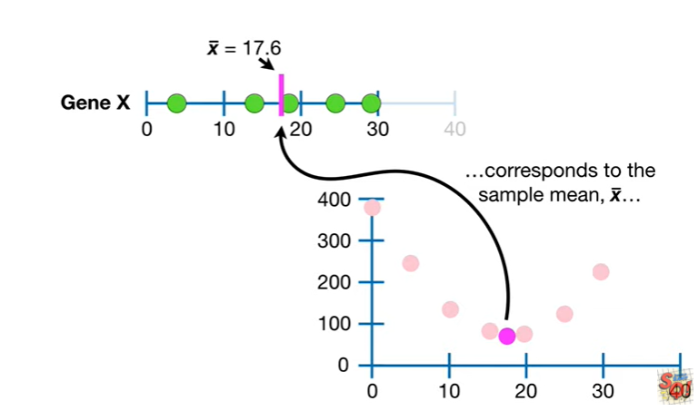

corresponds to the sample mean x-bar

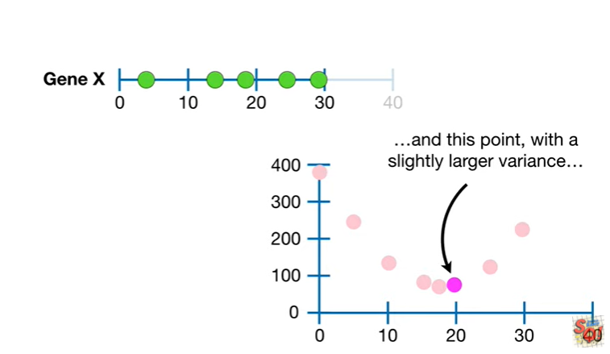

and this point with a slightly larger variance

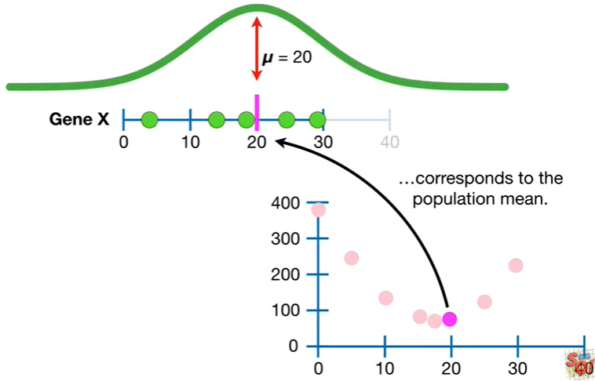

corresponds to the population mean.

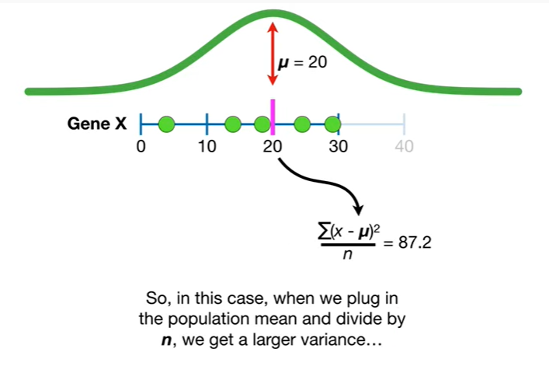

So in this case when we plug in the population mean and divide by n we get a larger variance

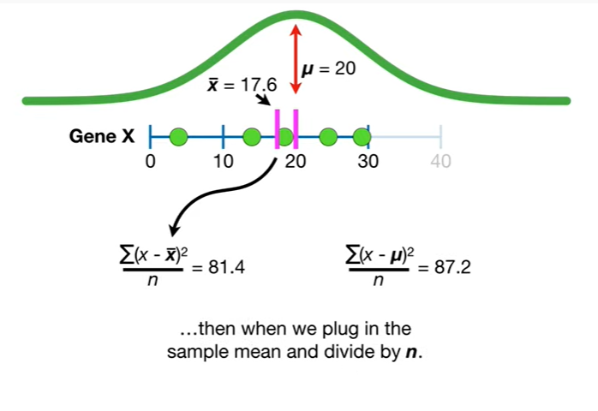

then when we plug in the sample mean and divide by n.

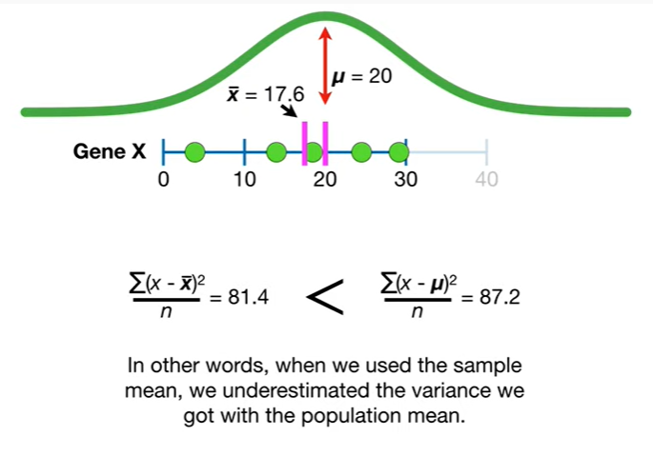

In other words when we use the sample mean we underestimated the variance we got with the population mean.

BAM !!!

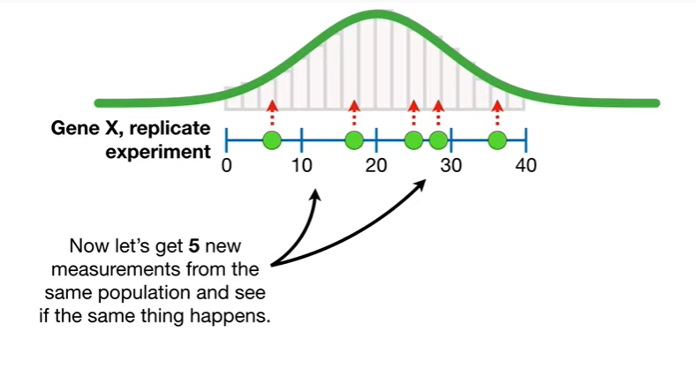

Now let's get 5 new measurements from the same population and see if the same thing happens .

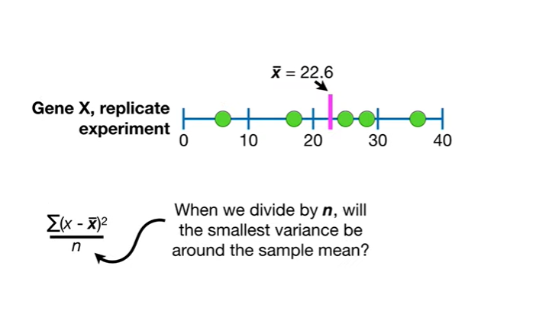

When we divide by n with a smallest variance be around the sample mean ?

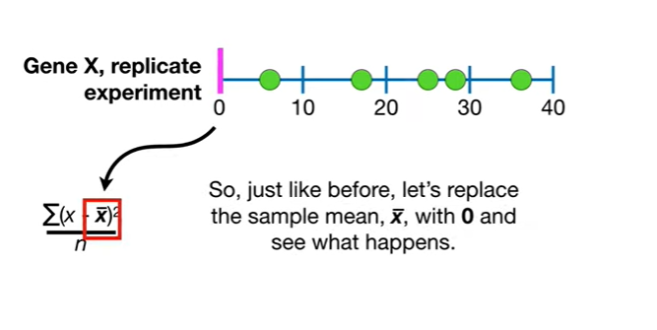

So just like before let's replace the sample mean x-bar with zero and see what happens.

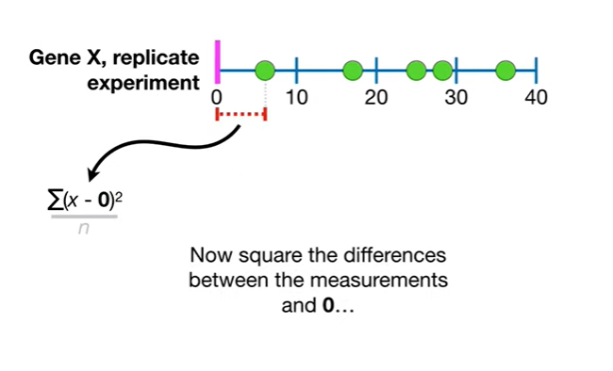

Now square the differences between the measurements and zero

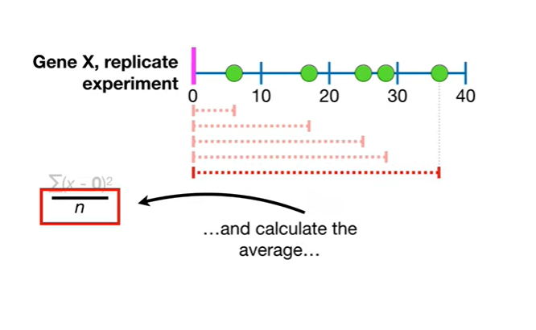

calculate the average

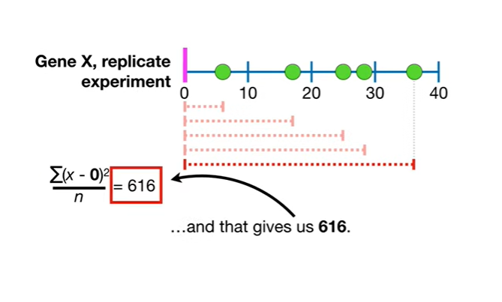

that gives us 616.

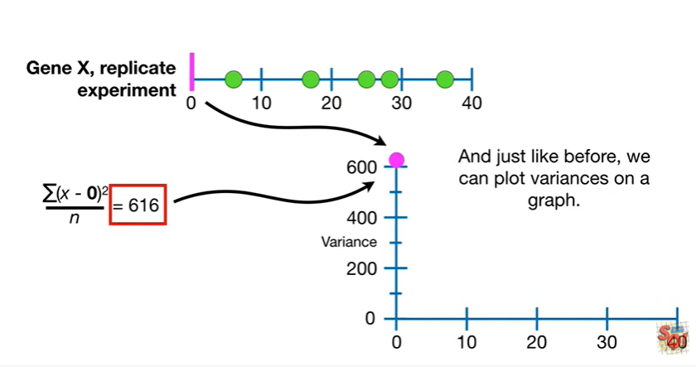

And just like before we can plot variances on the graph.

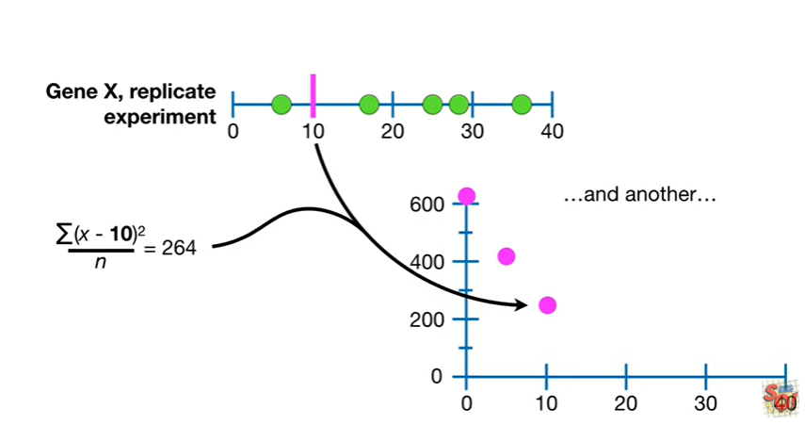

Here's another point and another and another.

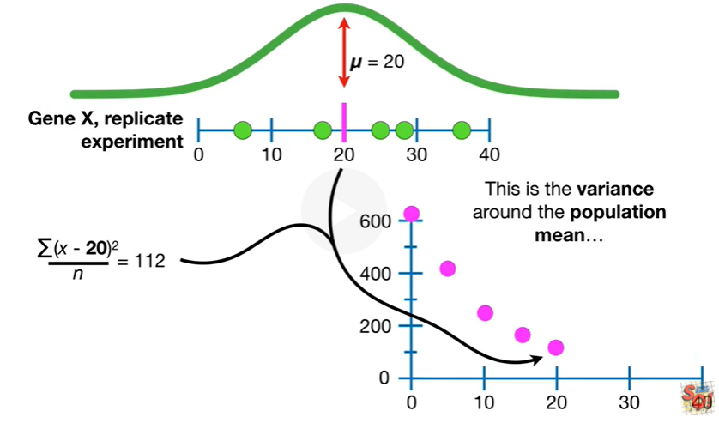

This is the variance around the population mean

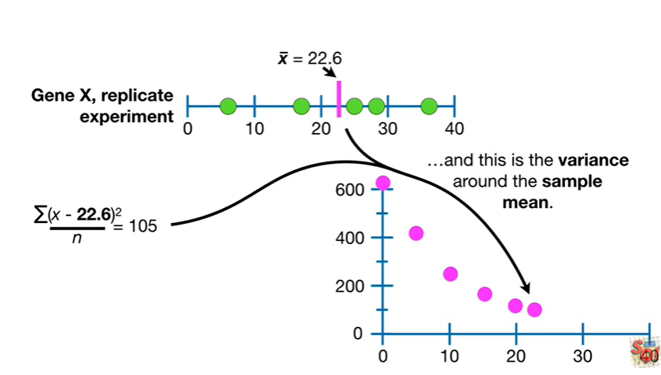

and this is the variance around the sample mean.

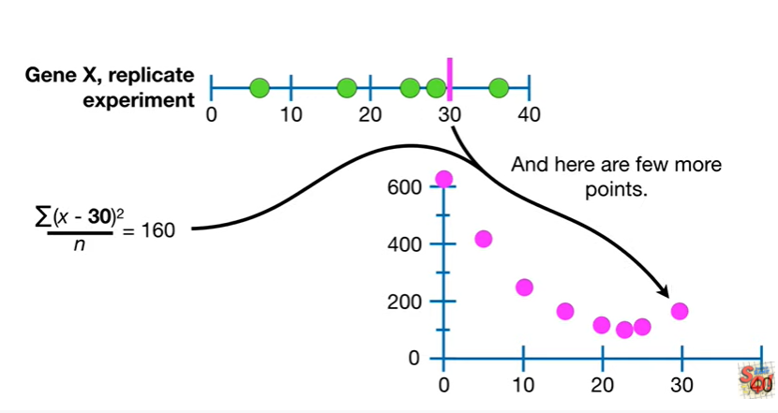

And here are a few more points.

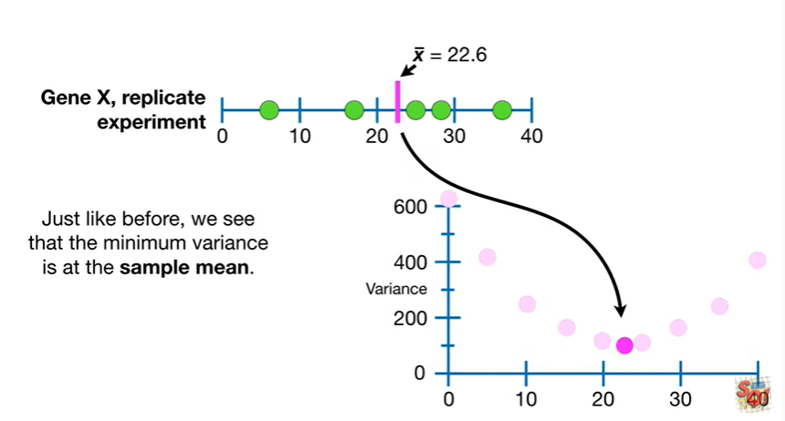

Just like before we see that the minimum variance is at the sample mean.

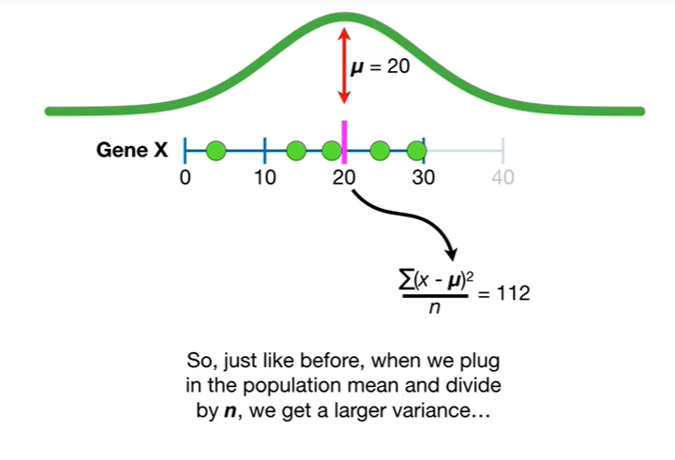

So just like before when we plug in the population mean and divide by n we get a larger variance

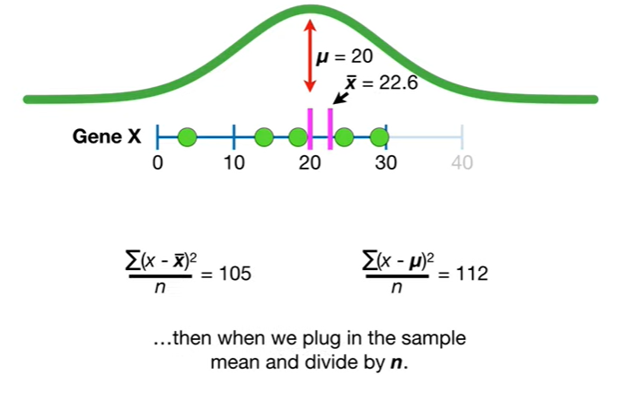

then when we plug in the sample mean and divide by n.

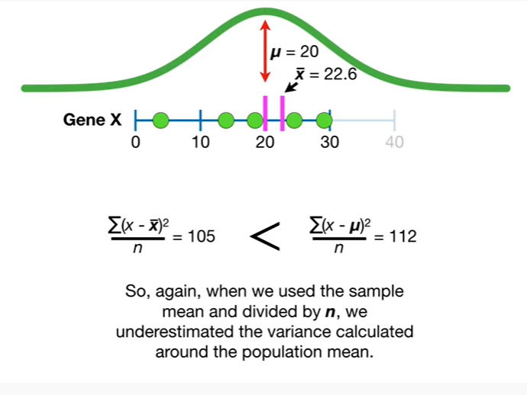

So again when we use the sample mean and divided by n we underestimated the variance calculated around the population mean.

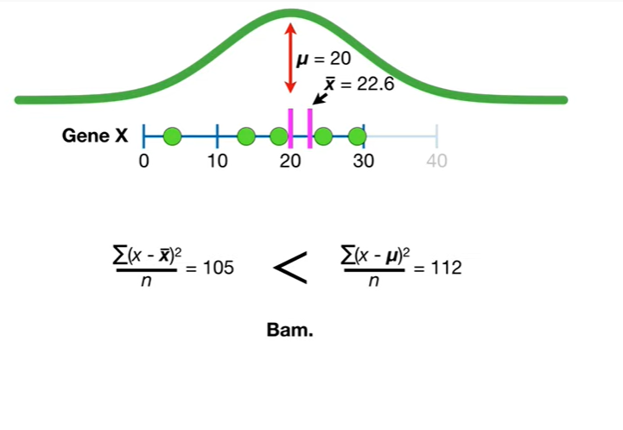

BAM !!!

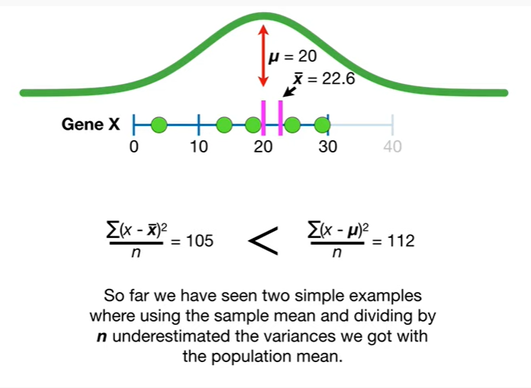

So far we have seen two simple examples where using the sample mean and dividing by n underestimated the variance as we got with the population mean.

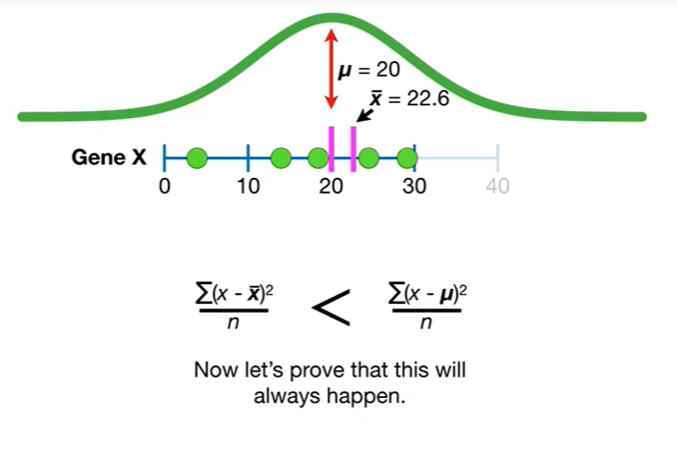

Now let's prove that this will always happen.

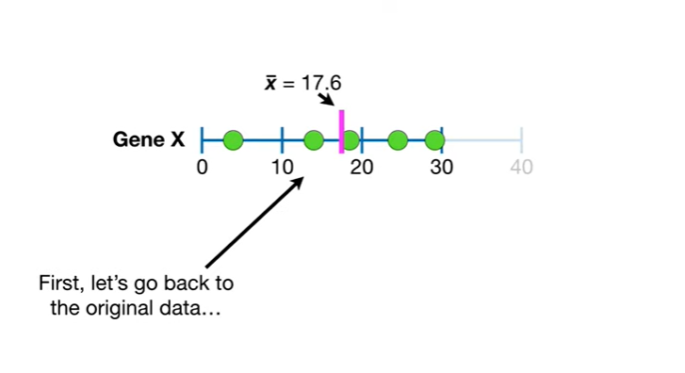

First let's go back to the original data

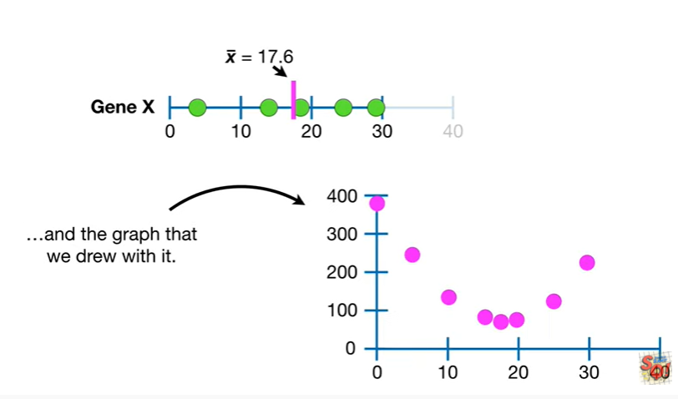

and the graph that we drew with it.

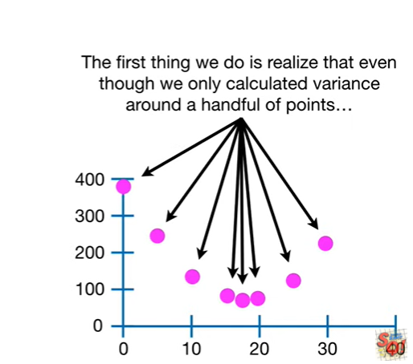

The first thing we do is realize that even though we only calculated variance around a handful of points

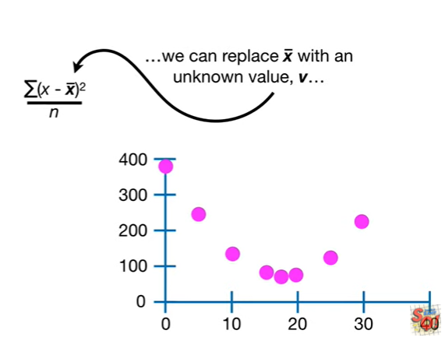

we can replace X bar with an unknown value V

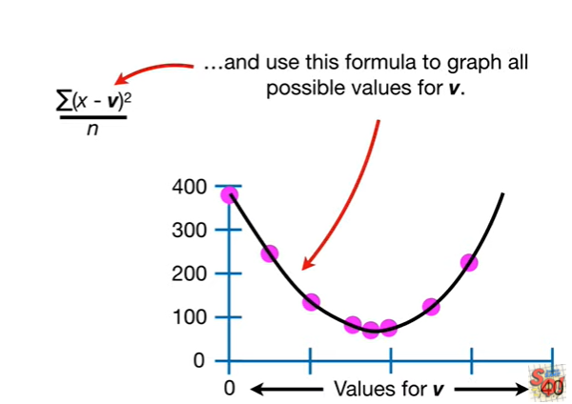

and use this formula to graph all possible values for V.

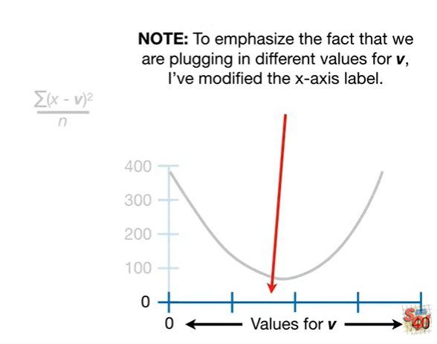

Note : to emphasize the fact that we are plugging in different values for V I've modified the X axis label.

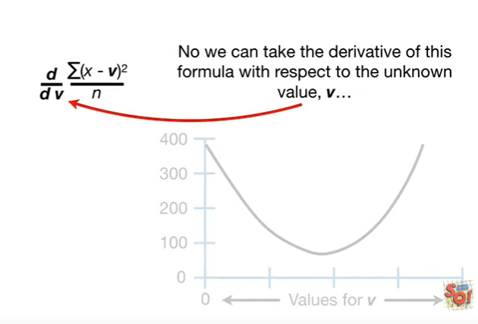

No we can take the derivative of this formula with respect to the unknown value V

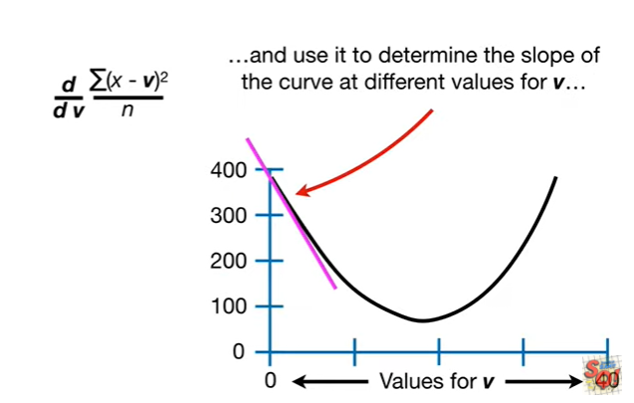

and use it to determine the slope of the curve at different values for V

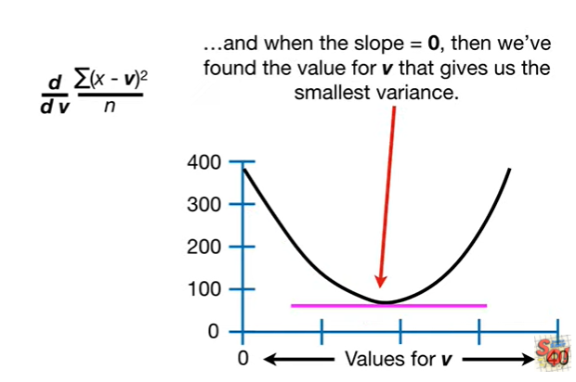

and the slope equals zero then we found the value for V that gives us the smallest variance.

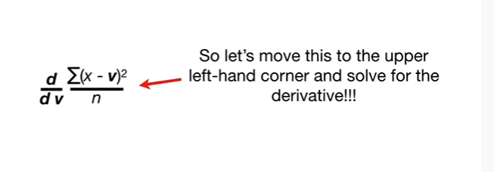

So let's move this to the upper left hand corner and solve for the derivative !!!!

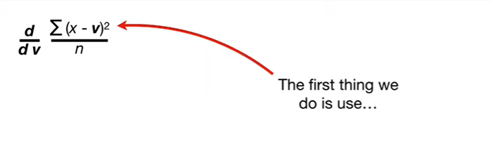

The first thing we do is use

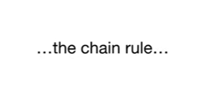

the chain rule what the chain rule

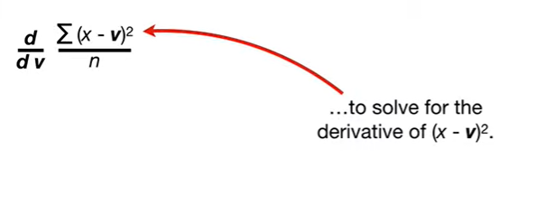

to solve for the derivative of X minus V squared.

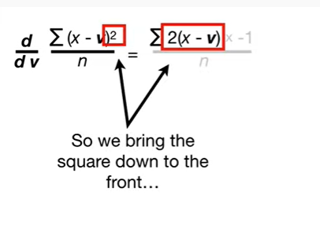

So we bring the square down to the front

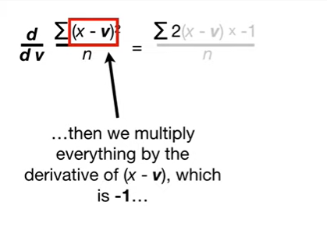

and then we multiply everything by the derivative of X minus V which is negative one

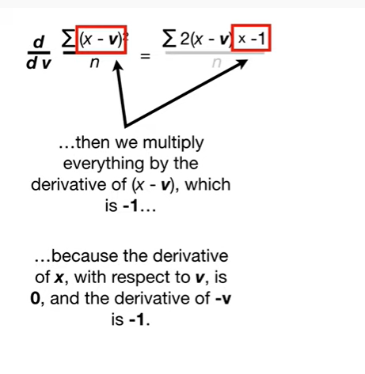

because the derivative of X with respect to V is zero and the derivative of negative V is negative one

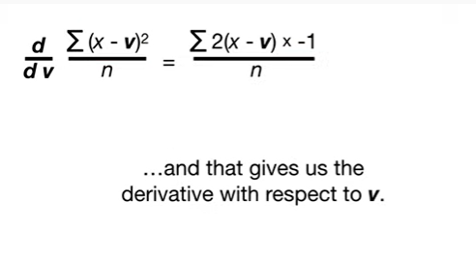

and that gives us the derivative with respect to v.

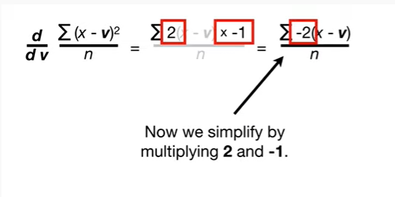

Now we simplify by multiplying 2 and negative 1.

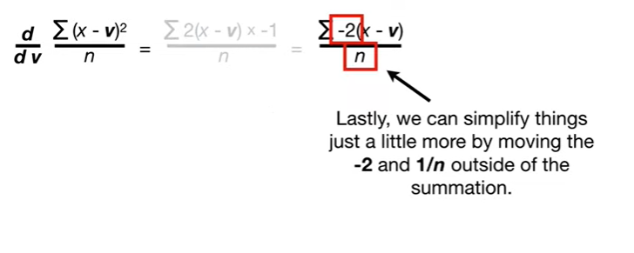

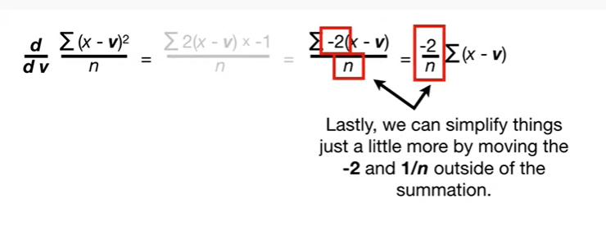

Lastly we can simplify things just a little more by moving the negative 2 and 1 divided by n outside of the summation.

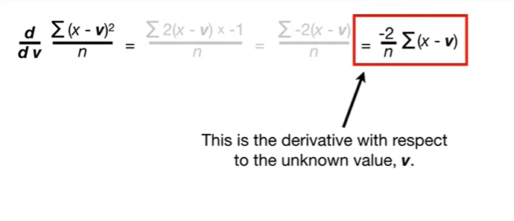

This is the derivative with respect to the unknown value, v.

BAM !

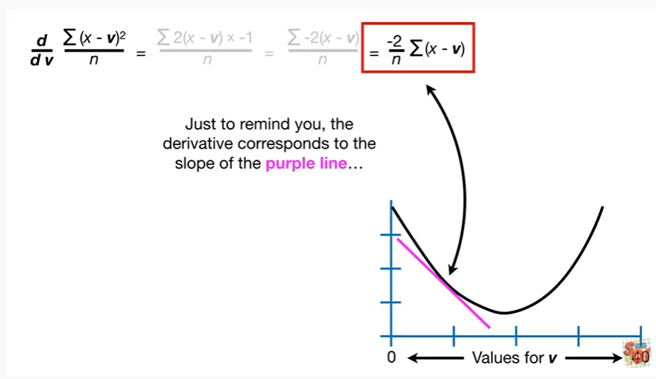

Just to remind you the derivative corresponds to the slope of the Purple Line

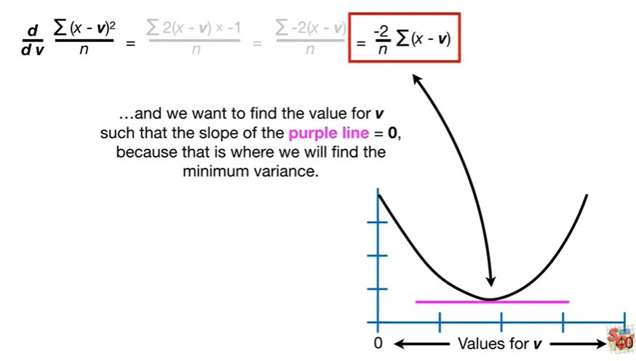

and we want to find the value for V such that the slope of the Purple Line equals zero because that is where we will find the minimum variance.

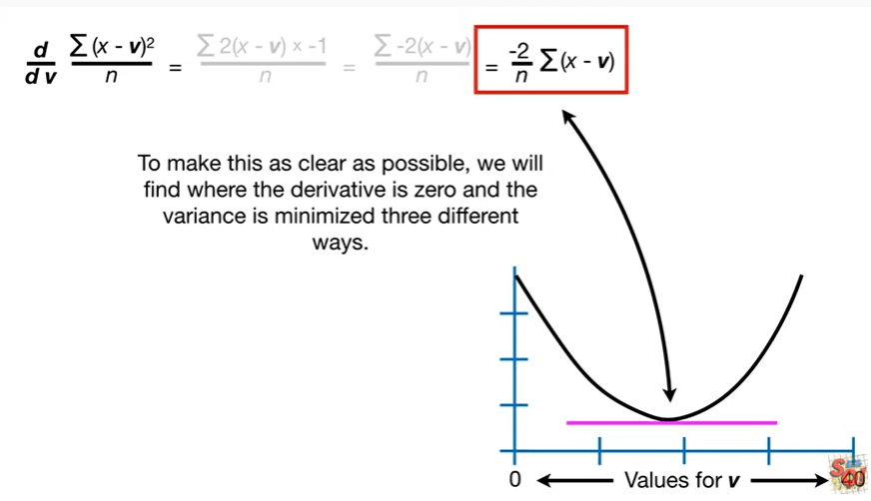

To make this as clear as possible we will find where the derivative is zero and the variance is minimized three different ways.

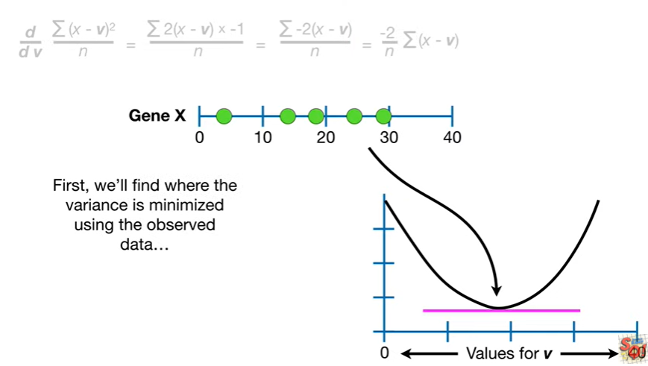

First we'll find where the variance is minimized using the observed data

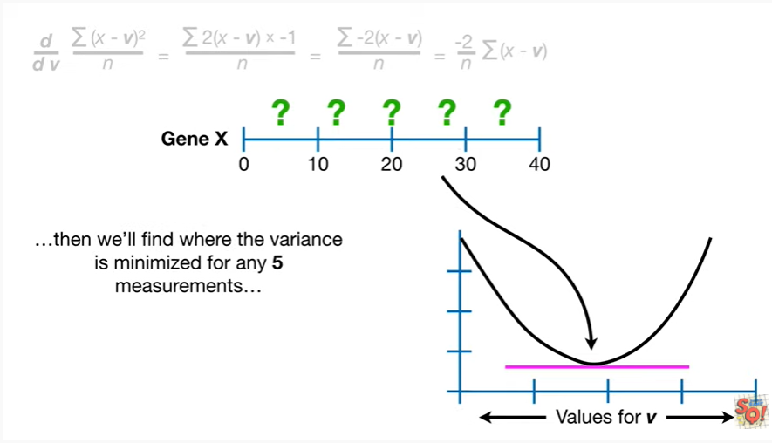

then we'll find where the variance is minimized for any five measurements

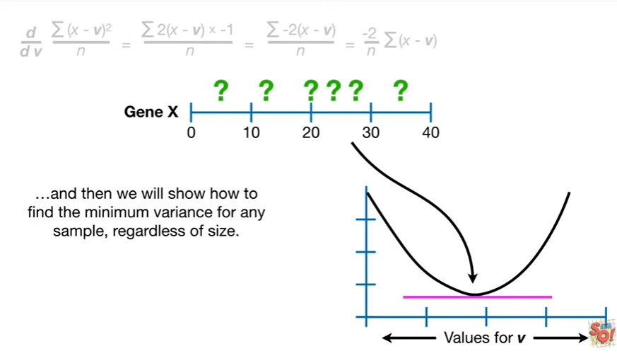

and then we'll show how to find the minimum variance for any sample regardless of size.

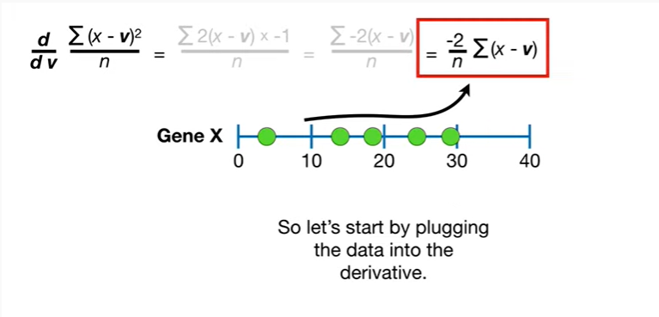

So let's start by plugging the data into the derivative.

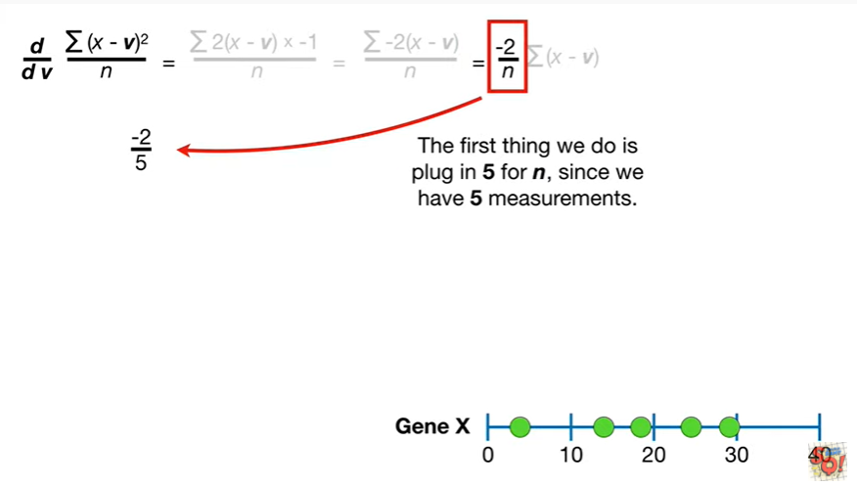

The first thing we do is plug in 5 for n since we have 5 measurements

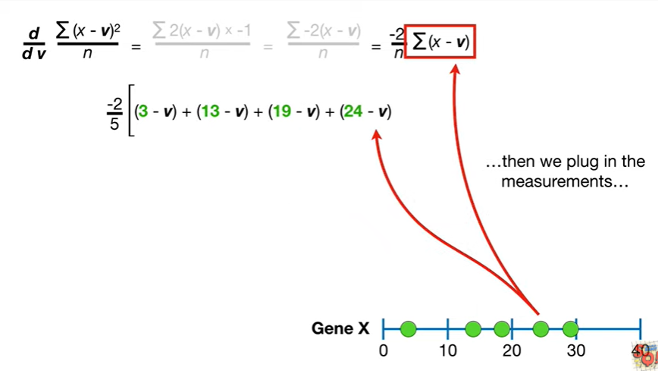

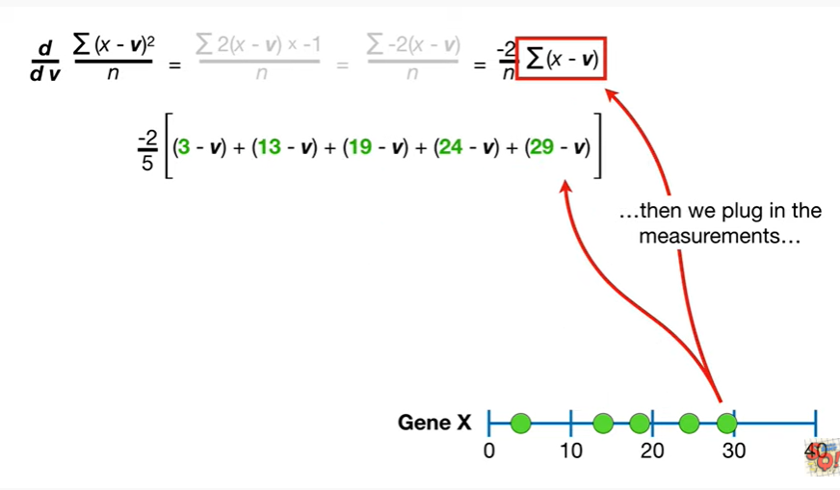

then we plug in the measurements.

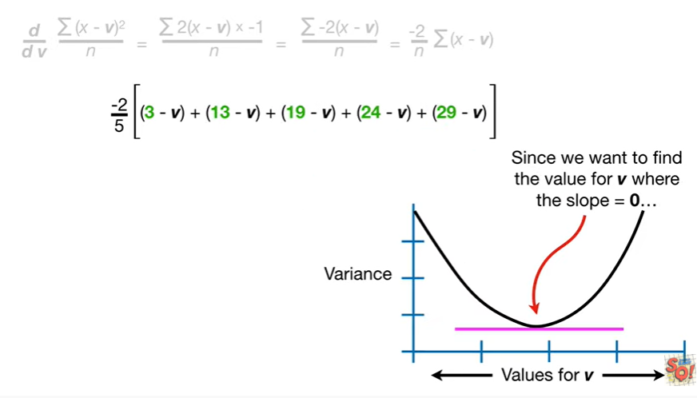

Since we want to find the value for V where the slope equals zero

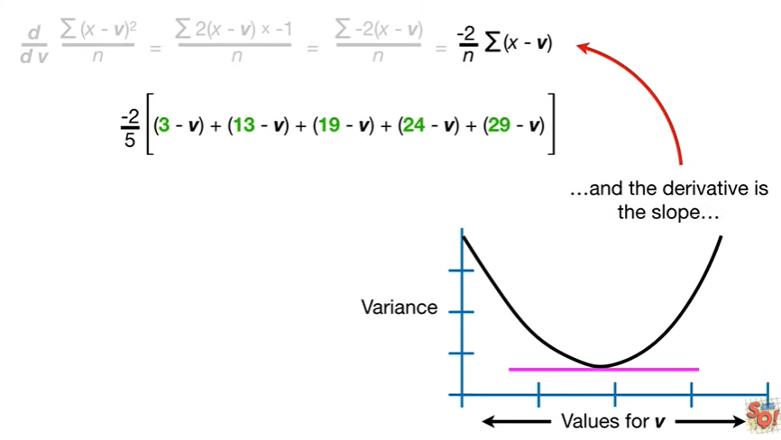

and the derivative is the slope

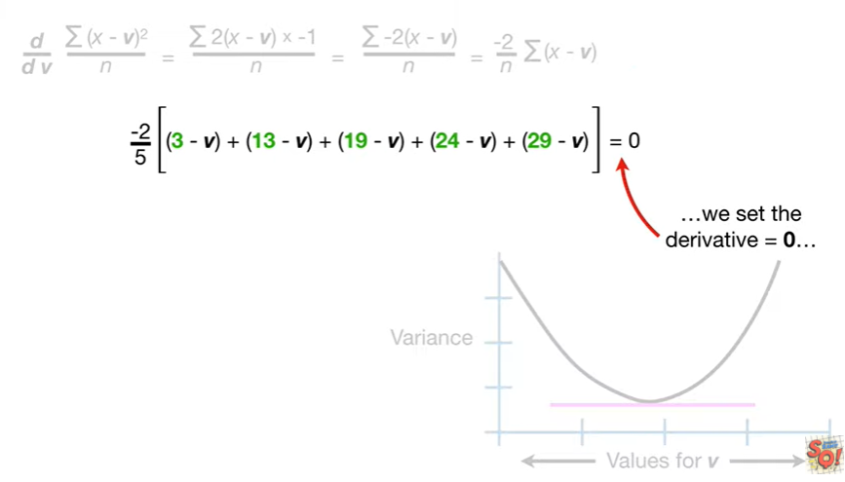

we set the derivative equal to zero

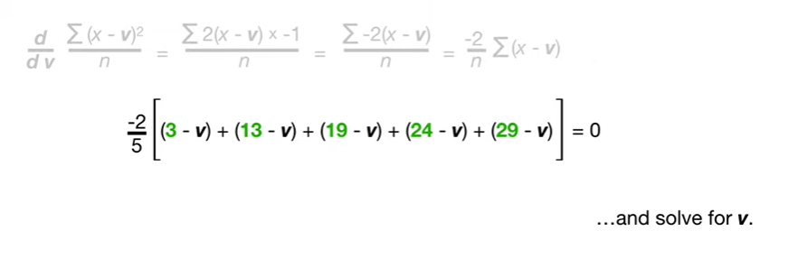

and solve for v.

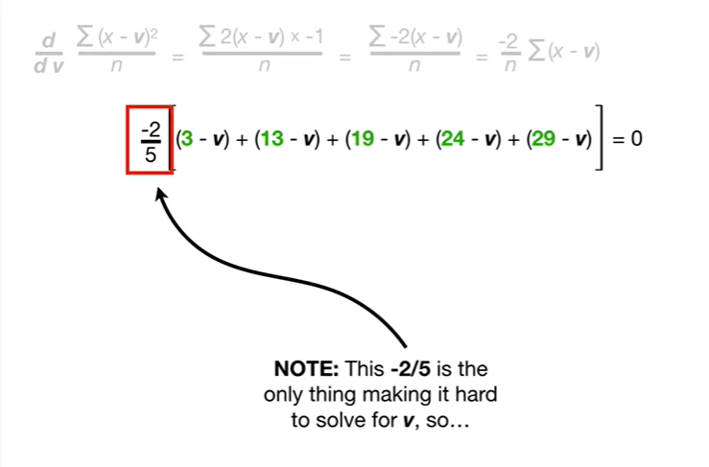

Note : this negative 2/5 is the only thing making it hard to solve for V, so

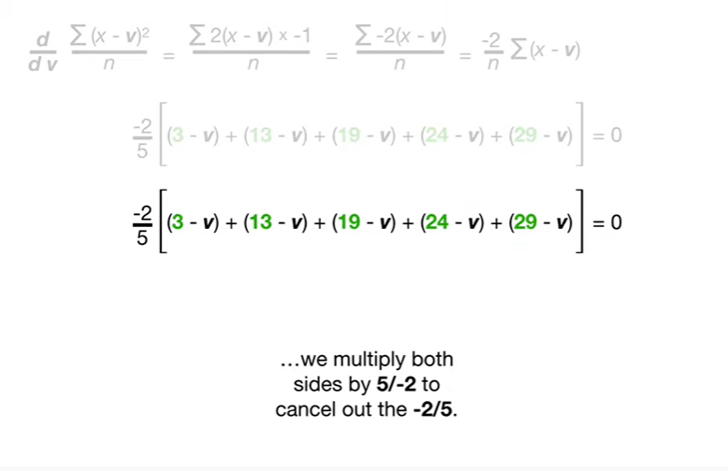

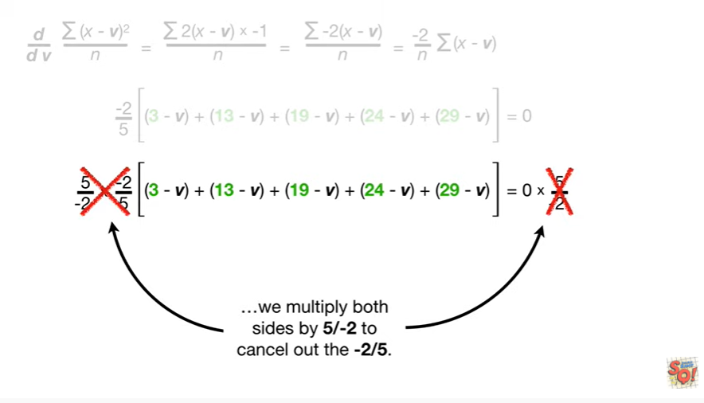

we multiply both sides by 5 divided by negative 2 to cancel out the negative 2/5.

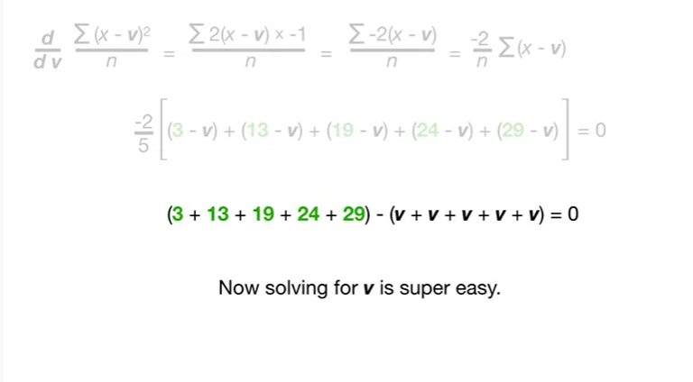

Now solving for V is super easy.

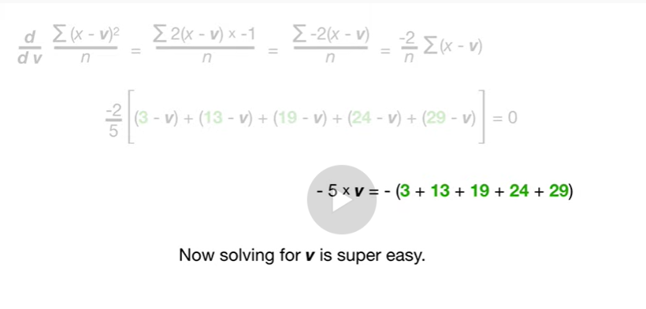

boo boo boo boo boo boo boo boo boo.

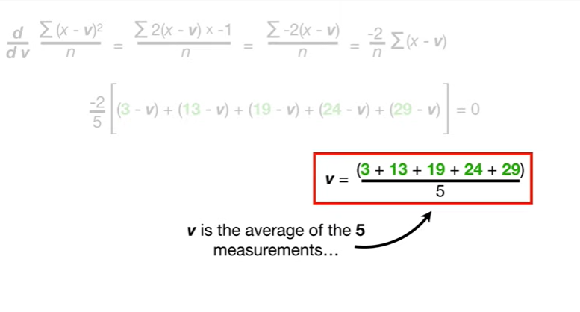

V is the average of the five measurements

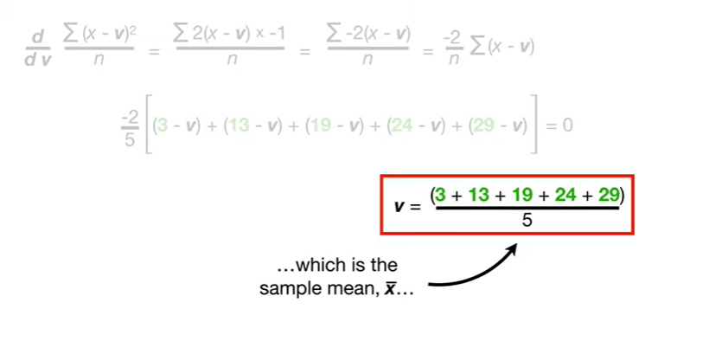

which is the sample mean x-bar

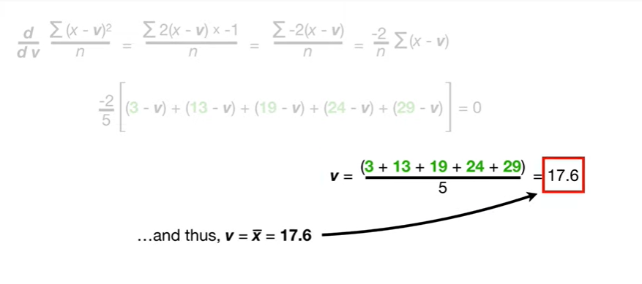

and thus V equals x-bar which equals seventeen point six.

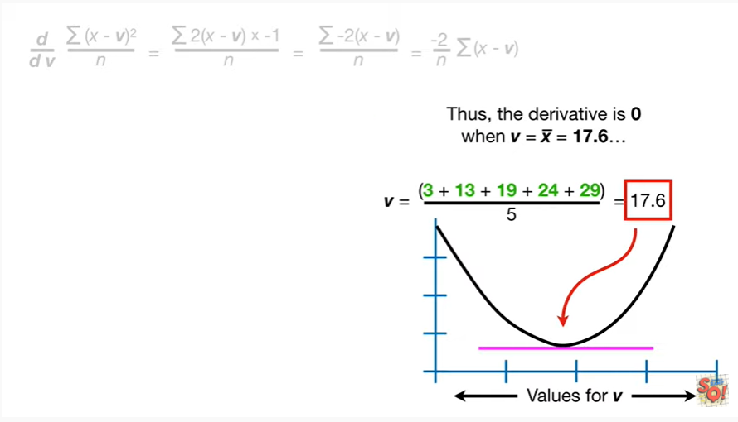

Thus the derivative is zero when V equals x-bar which equals seventeen point six

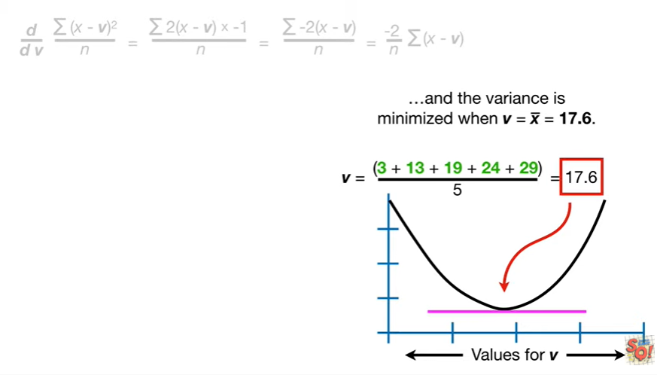

and the variance is minimized when V equals x-bar which equals seventeen point six.

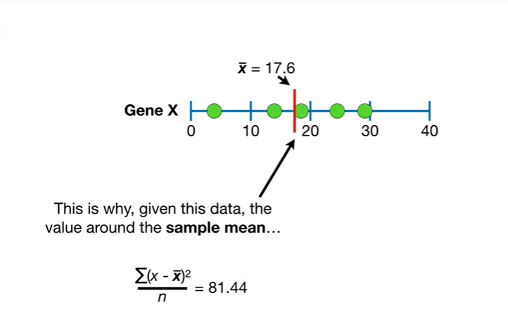

This is why given this data the value around the sample mean

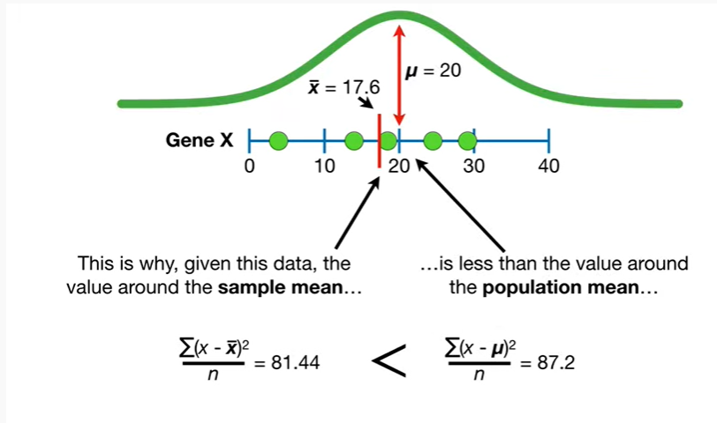

is less than the value around the population mean.

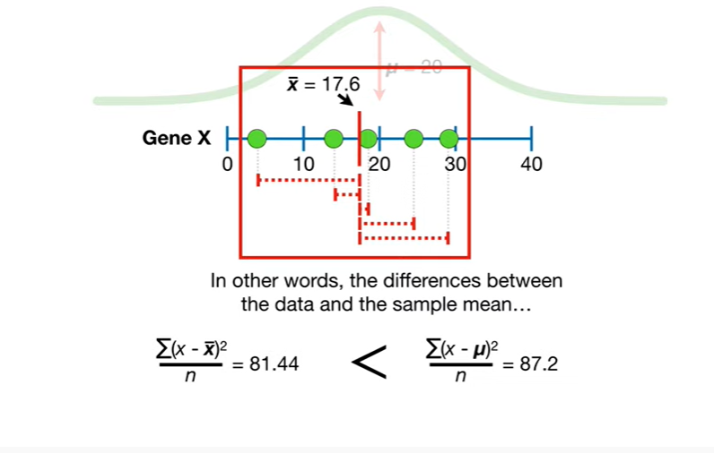

In other words the differences between the data and the sample mean

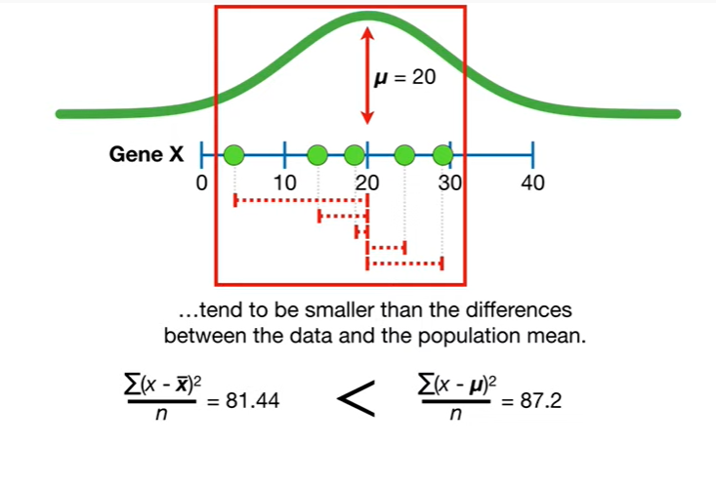

tend to be smaller than the differences between the data and the population mean.

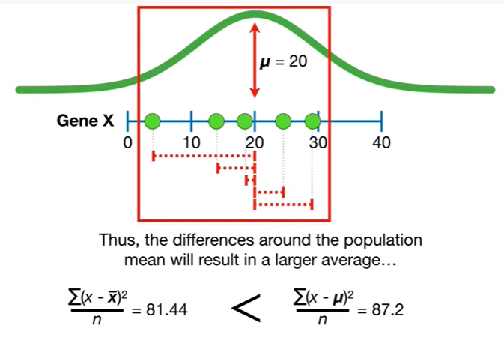

Thus the differences around the population mean will result in a larger average

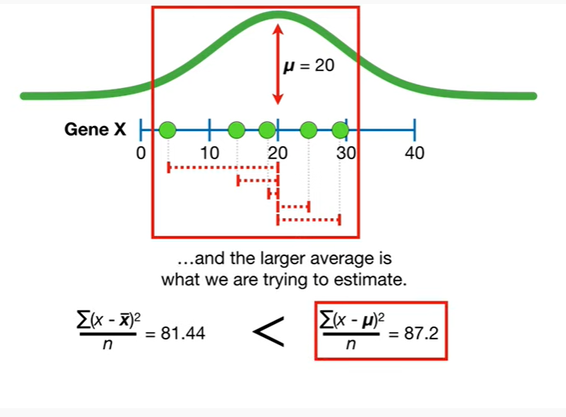

and the larger average is what we are trying to estimate.

BAM !!

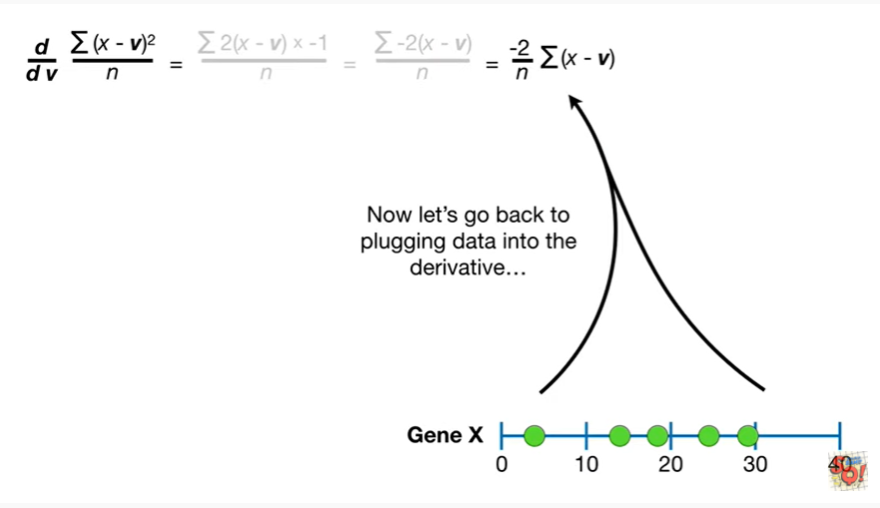

Now let's go back to plugging data into the derivative

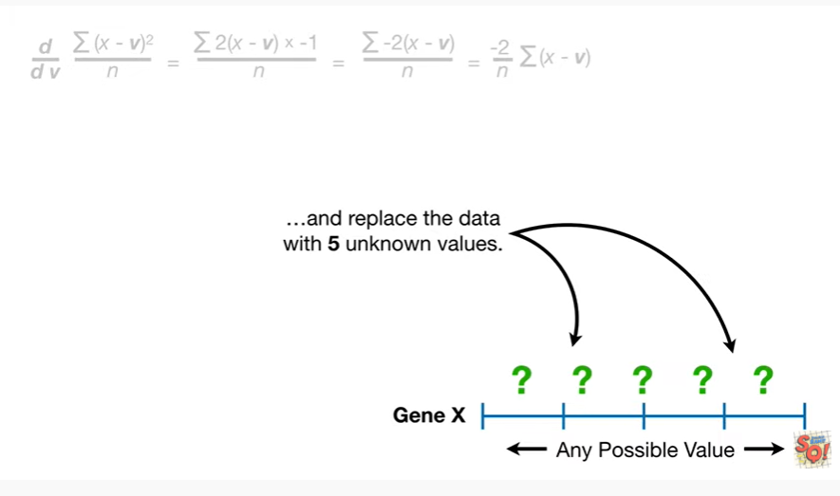

and replace the data with five unknown values.

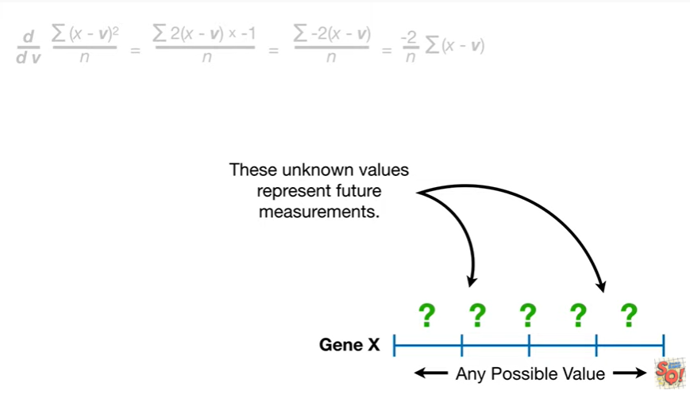

These unknown values represent future measurements.

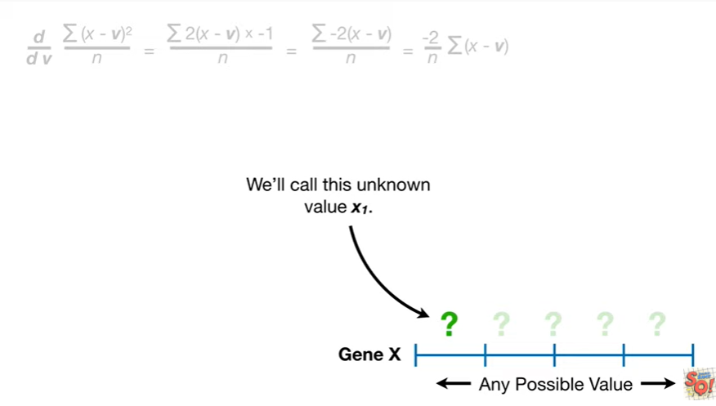

We'll call this unknown value X sub one.

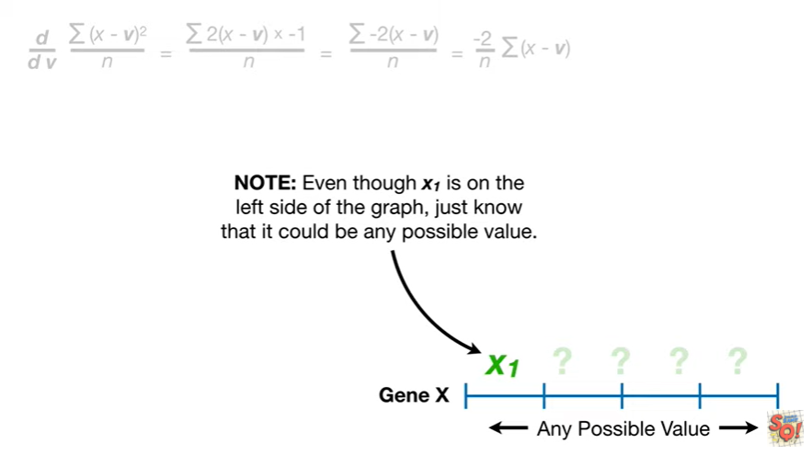

Note : even though X sub one, is on the left side of the graph, just know that it could be any possible value.

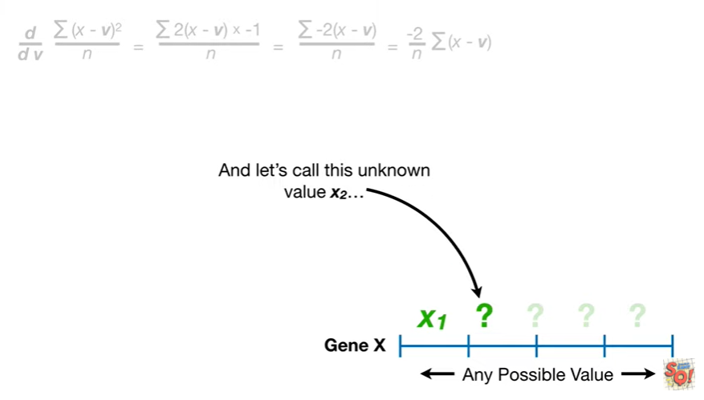

And let's call this unknown value X sub 2

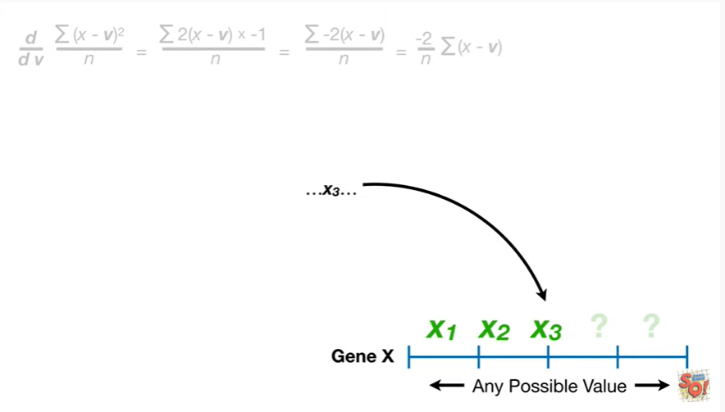

X sub 3 of four

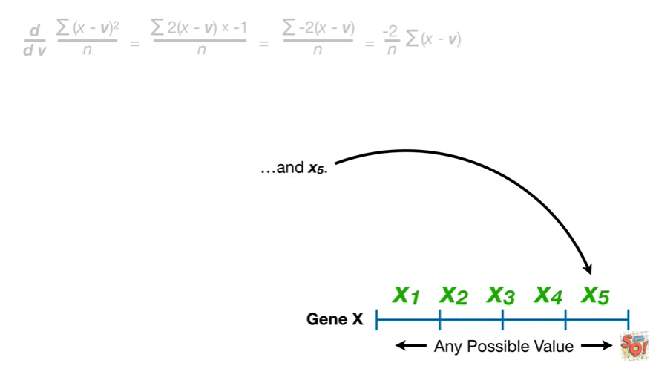

and X sub 5.

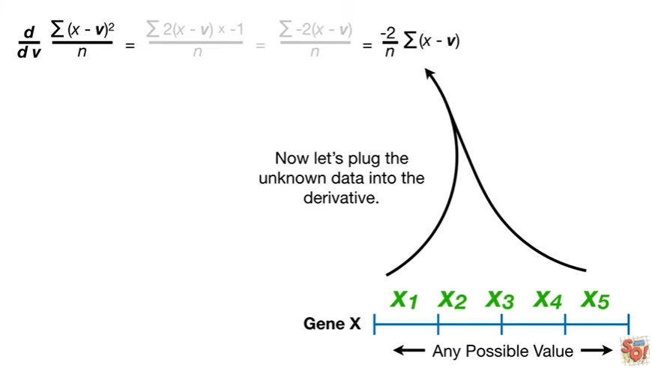

Now let's plug the unknown data into the derivative.

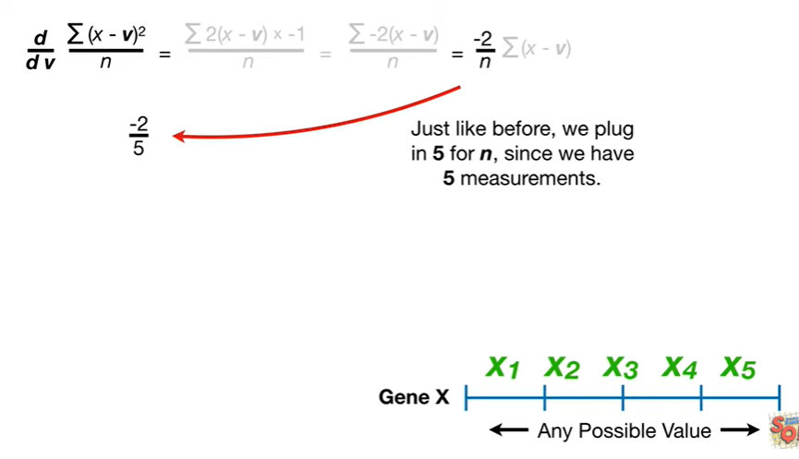

Just like before we plug in five four in since we have five measurements

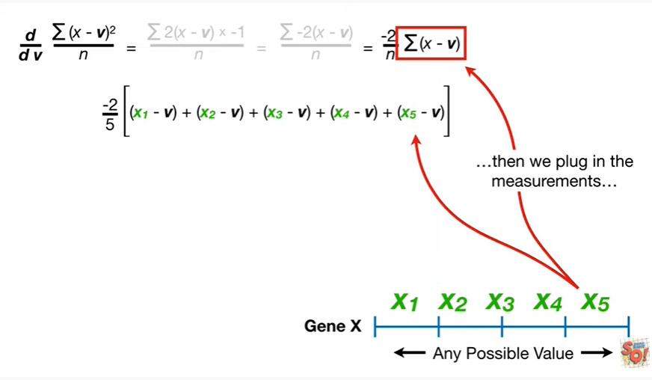

then we plug in the measurements.

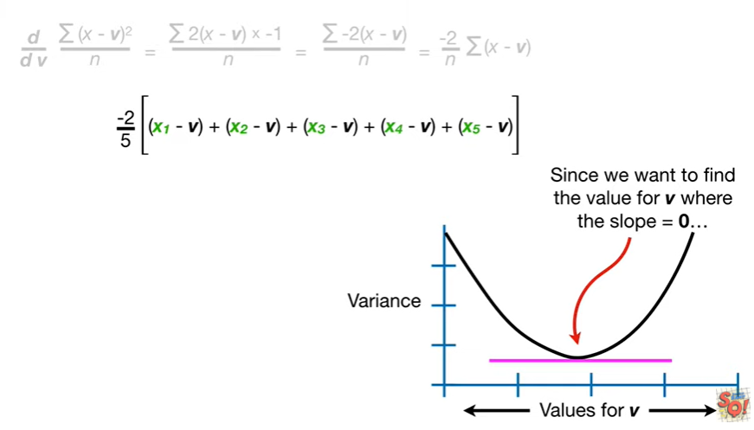

Since we want to find the value for V where the slope equals zero we set the derivative equal to zero

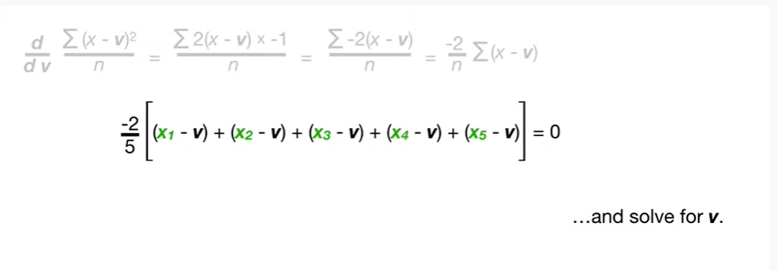

and solve for V.

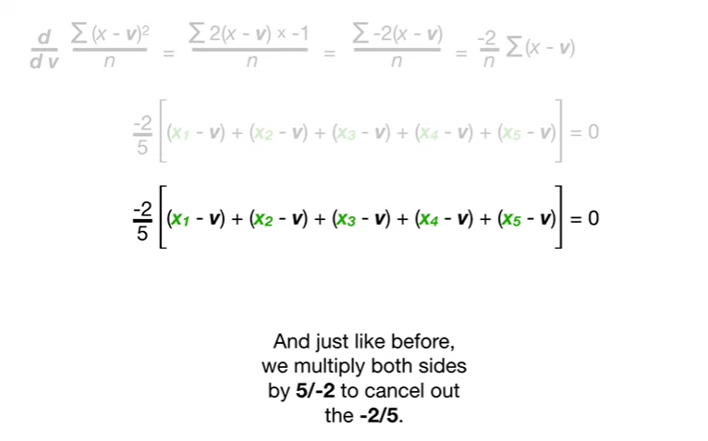

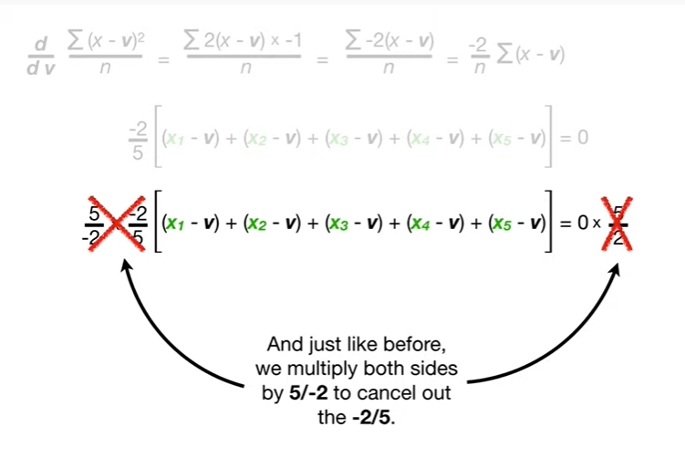

And just like before we multiply both sides by 5 divided by negative 2 to cancel out the negative 2/5.

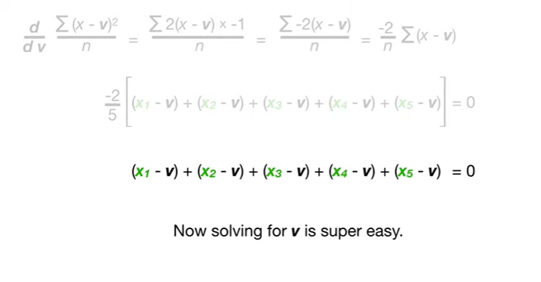

Now solving for V is super easy.

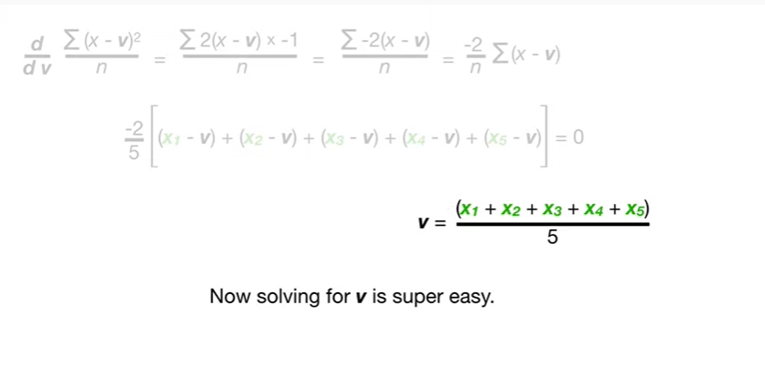

boo-boo-boo-boo-boo-boo-boop boom boom

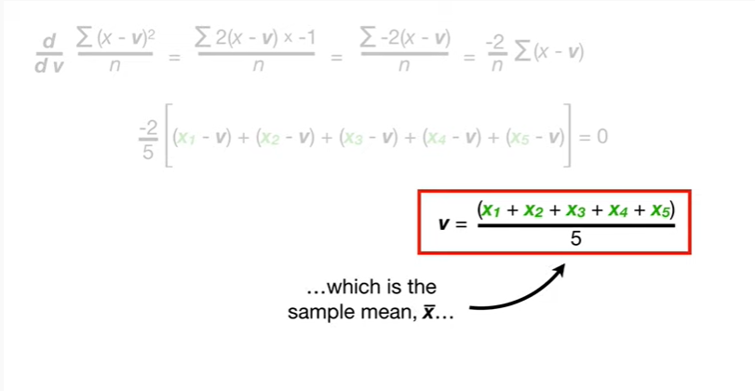

V is the average of the five measurements which is the sample mean x-bar

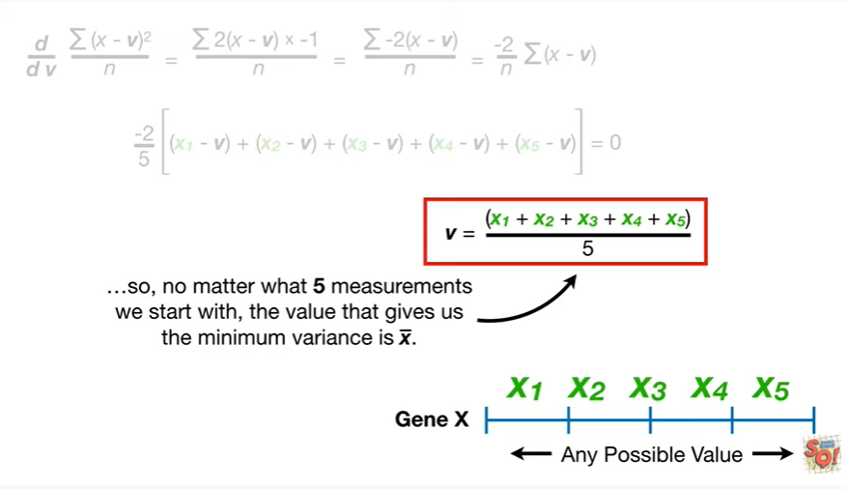

so no matter what five measurements we start with the value that gives us the minimum variance is x-bar.

BAM !!!

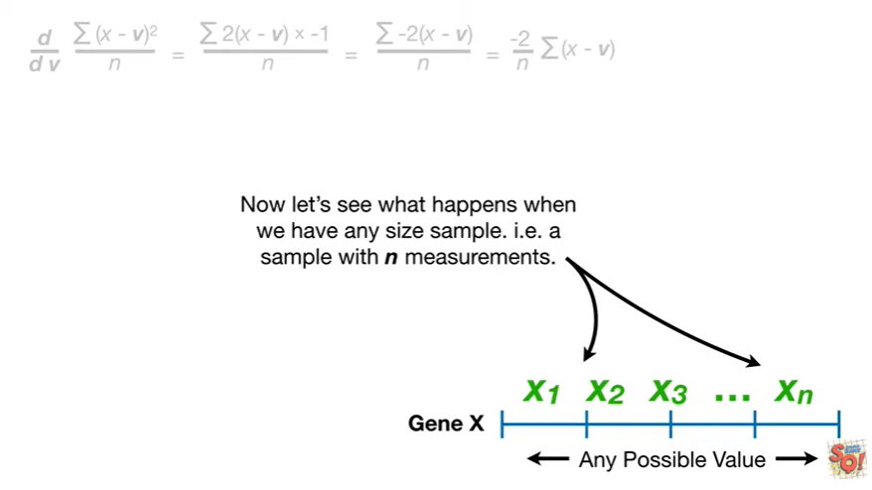

Now let's see what happens when we have any size sample ie a sample with in measurements.

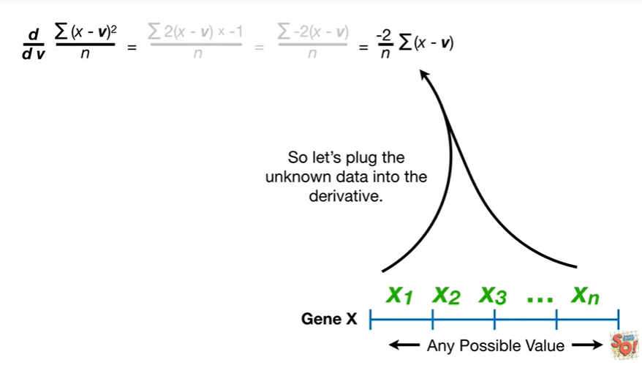

So let's plug the unknown data into the derivative.

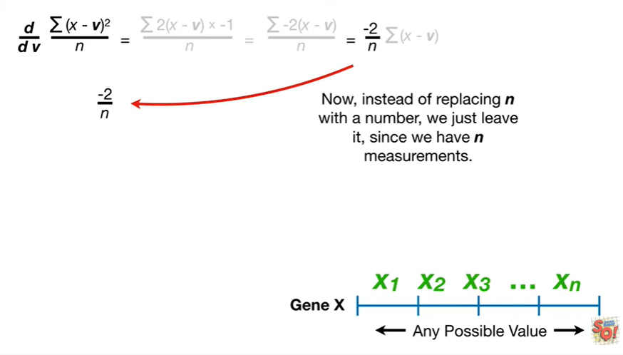

Now instead of replacing n with a number, we just leave it, since we have n measurements.

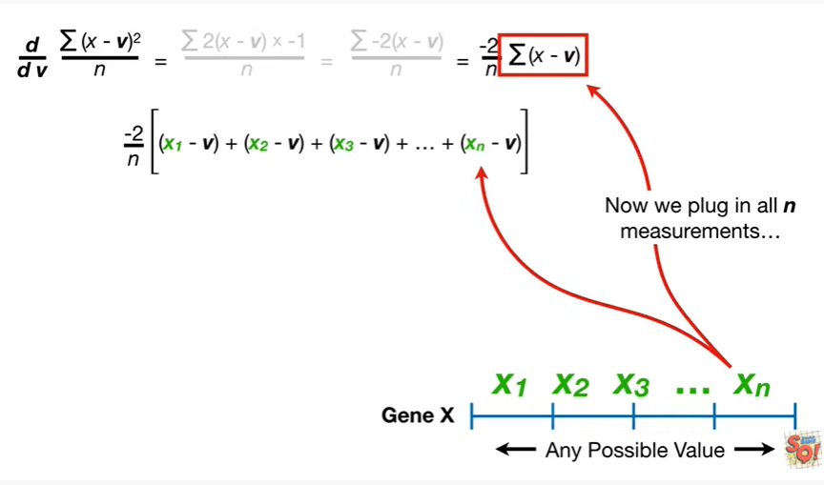

Now we plug in all in measurements

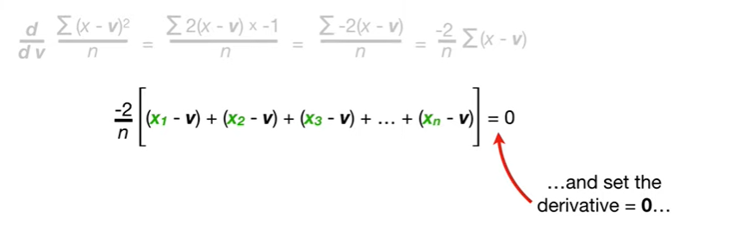

and set the derivative equal to zero

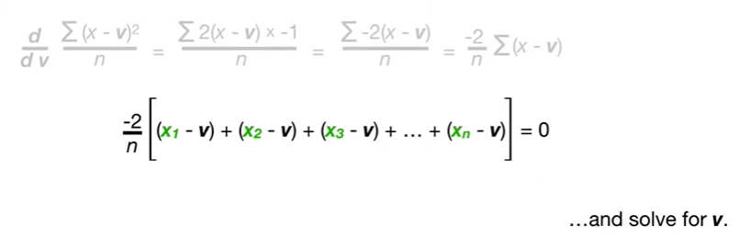

and solve for V.

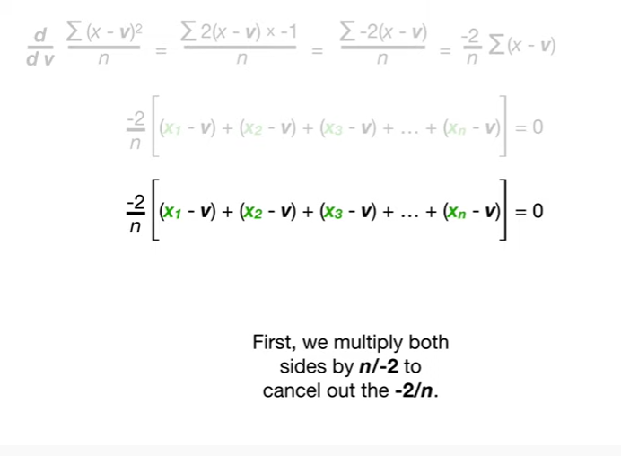

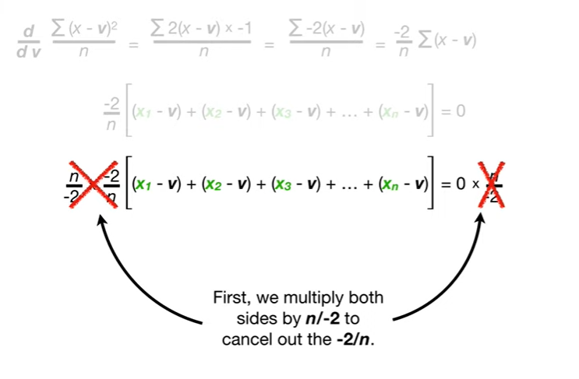

First we multiply both sides by n divided by negative 2 to cancel out the negative 2 divided by N.

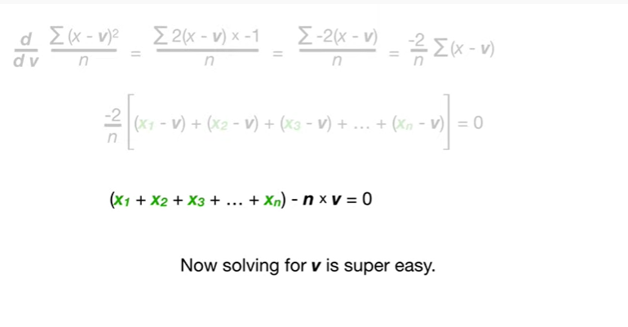

Now solving for V is super easy .

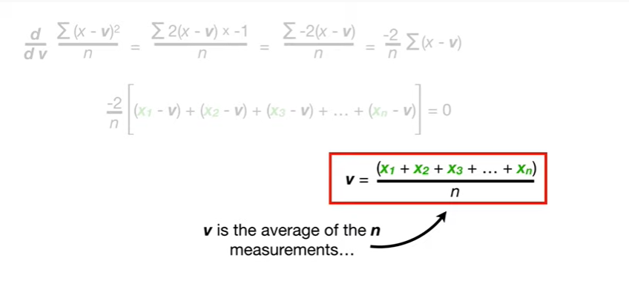

V is the average of the end measurements

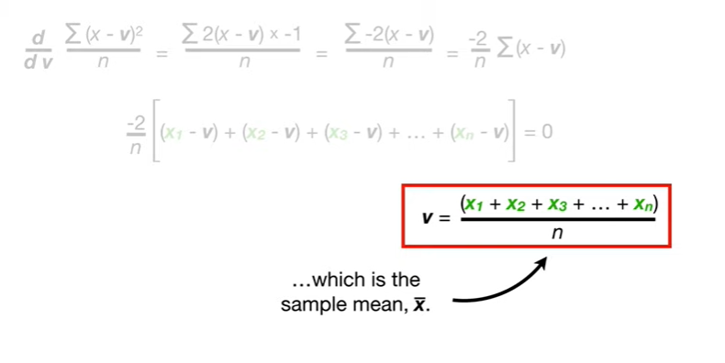

which is the sample mean x-bar.

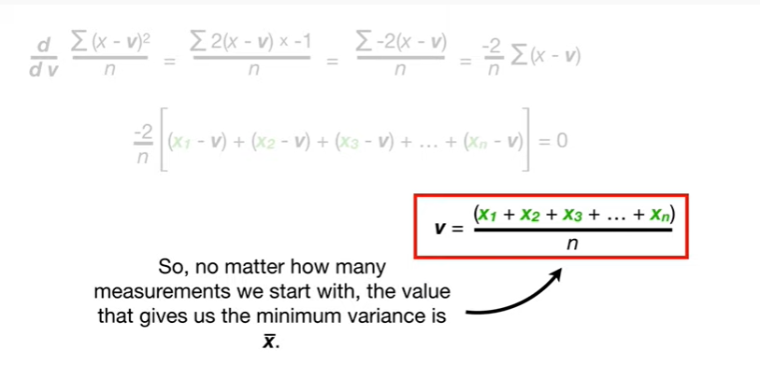

So no matter how many measurements we start with the value that gives us the minimum variance is X bar.

Double BAM !!!

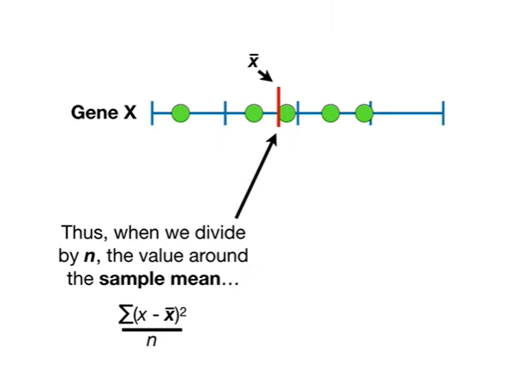

Thus when we divide by n, the value around the sample mean

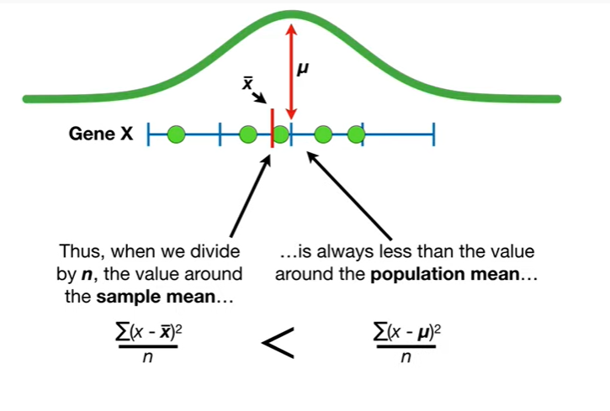

is always less than the value around the population mean

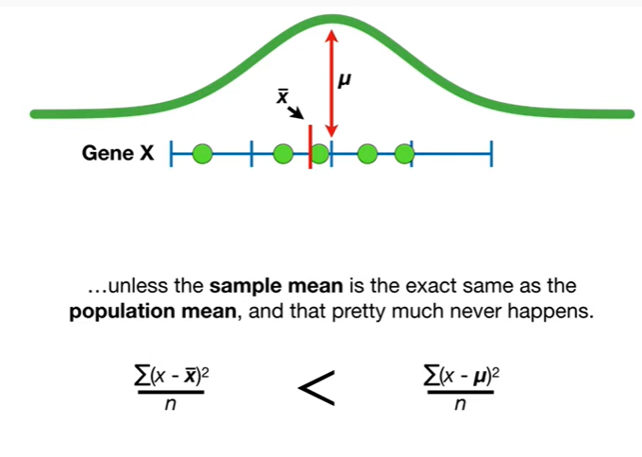

unless the sample mean is the exact same as the population mean and that pretty much never happens.

Triple bam !!!

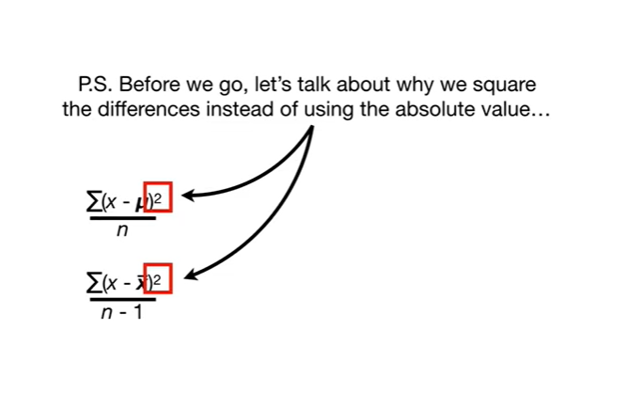

PS : Before we go let's talk about why we square the differences instead of using the absolute value.

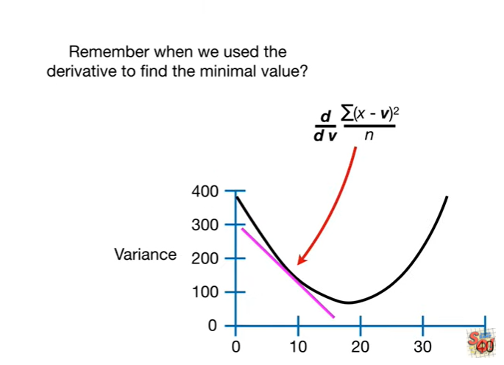

Remember when we use the derivative to find the minimal value ?

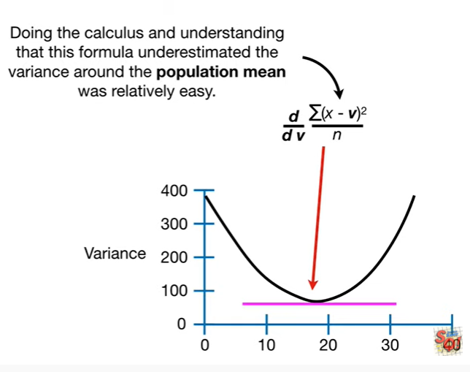

Doing the calculus and understanding that this formula underestimated the variance around the population mean was relatively easy.

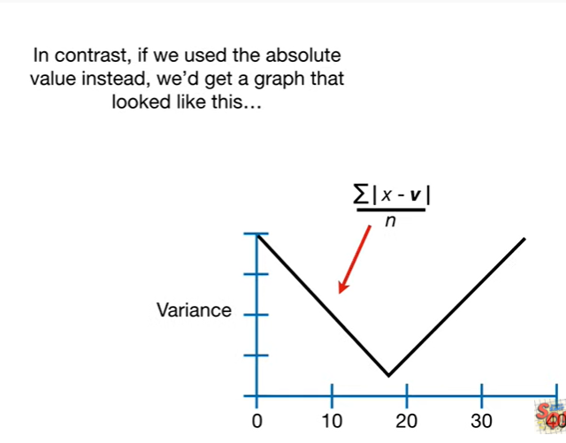

In contrast if we use the absolute value instead we'd get a graph that looked like this

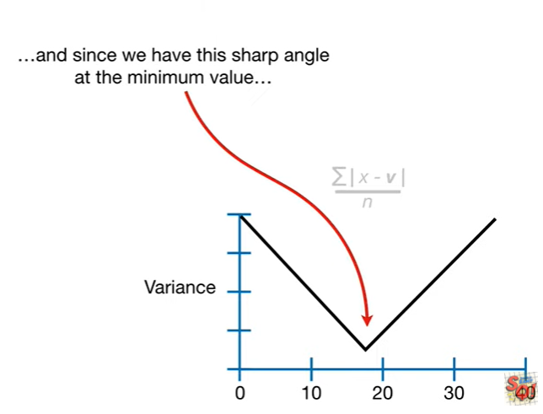

and since we have this sharp angle at the minimum value

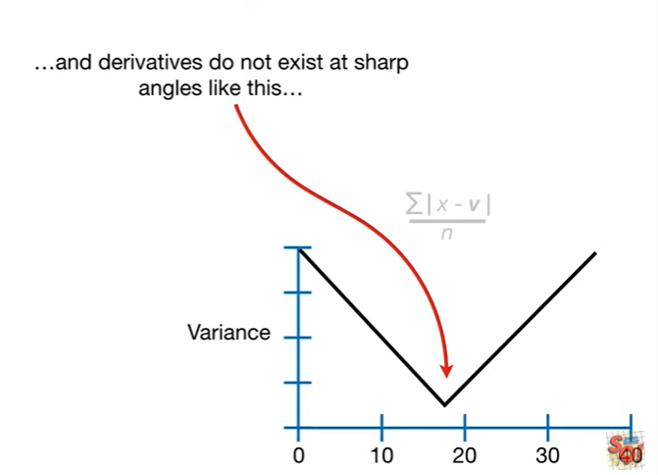

and derivatives do not exist at sharp angles like this

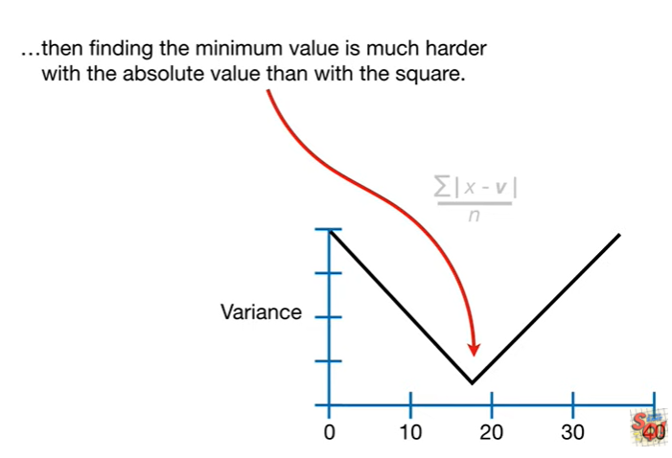

then finding the minimum value is much harder with the absolute value than with the square.

BAM !!!

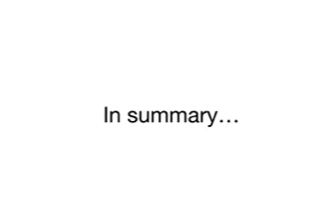

In summary :

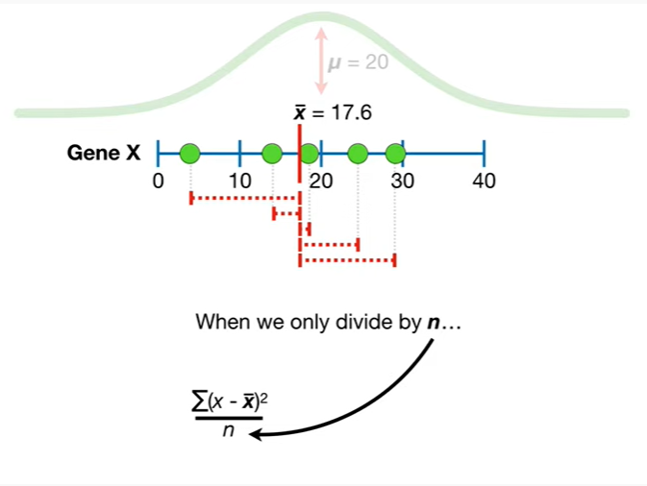

When we only divide by n

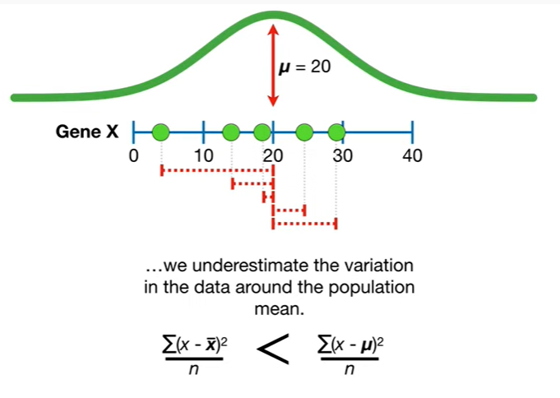

we underestimate the variation in the data around the population main.

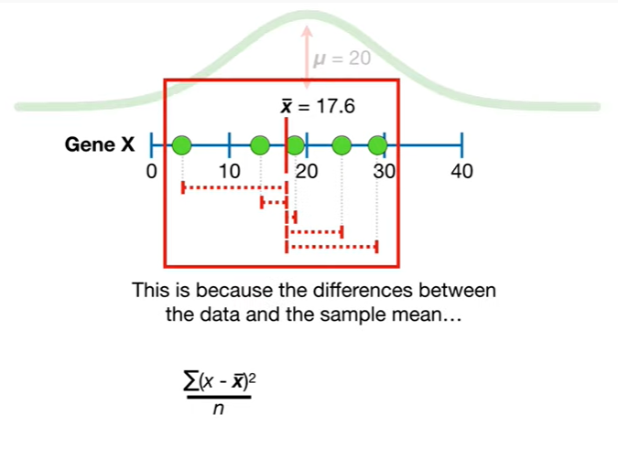

This is because the differences between the data and the sample mean

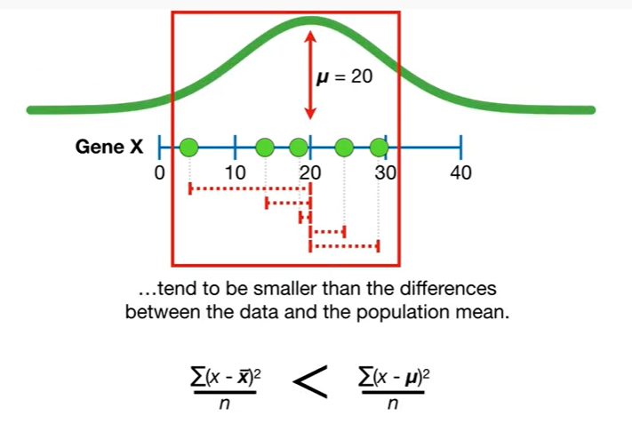

tend to be smaller than the differences between the data and the population mean.

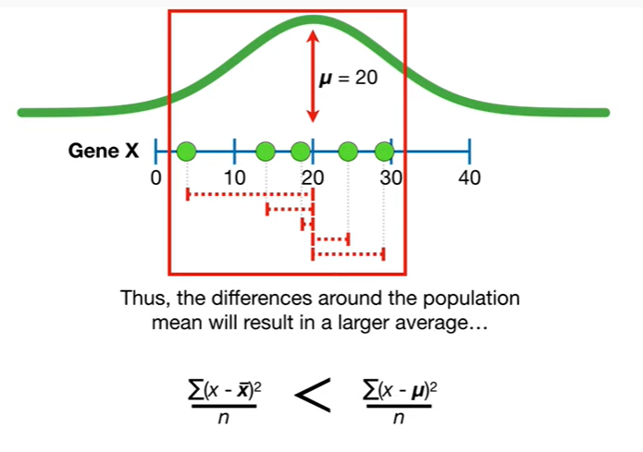

Thus the differences around the population mean will result in a larger average

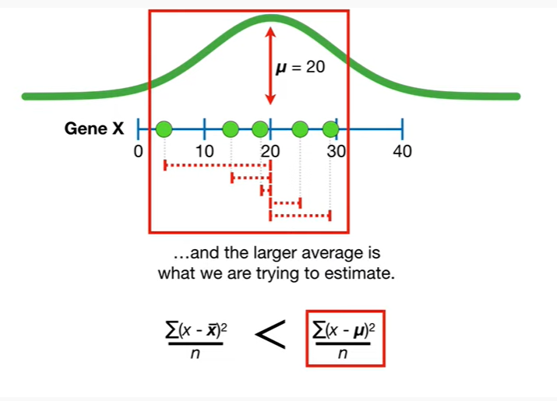

and the larger average is what we are trying to estimate.

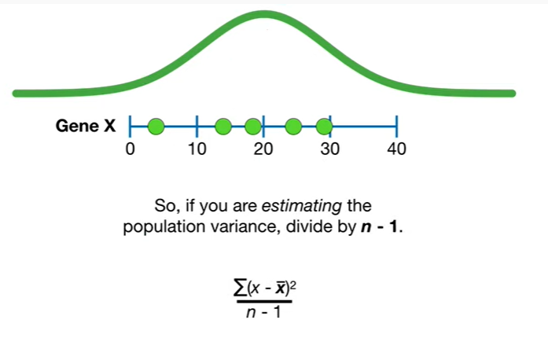

So, if you are estimating the population variance, divided by n minus one.

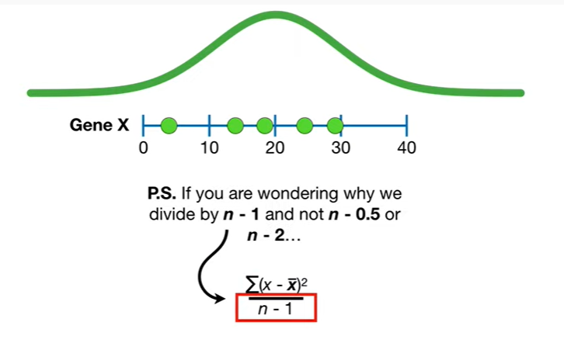

PS : if you're wondering why we divide by n minus 1 and not n minus 0.5 or n minus 2

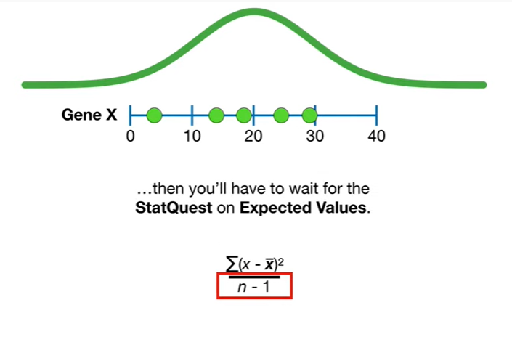

then you'll just have to wait for the stat quest on expected values.